**Alternatives using the Leap Motion for Mid-Air, Word-Gesture Keyboards**

# PRINCIPAL INVESTIGATOR: Garrett Benoit

103 Cottonwood Street, Waco, TX 76706

(832) 754-6923

[Garrett_Benoit@baylor.edu](mailto:Garrett_Benoit@baylor.edu)

CO- or SUB-INVESTIGATORS: N/A

STATISTICIAN: N/A

FUNDING AGENCY: N/A

PROTOCOL VERSION: 7/1/2015

**Synopsis**

|  |  |
| --- | --- |
| Title | Alternatives using the Leap Motion for Mid-Air, Word-Gesture Keyboards |
| Protocol Date | 7/1/2015 |
| Study Duration | 2 to 4 weeks (as long as it takes to schedule and run 18 participants) |
| Study location(s) | Rogers HCI Lab 310 |
| Objectives | To construct and compare new mid-air, word-gesture keyboards using the Leap Motion. The objective is to perform as well as or better than existing air-based word-gesture keyboard methods, specifically Vulture [9]. A further objective is to compare performance with conventional touch screen, word-gesture keyboards (e.g., smart phones, tablets) in hopes of bridging the gap. |
| Number of Subjects | 18 |
| Main Inclusion/Exclusion Criteria | Main Inclusion criteria is that the participant must be a Baylor Student, 18 years or older, who can sign a consent form for themselves. The subject must be able to speak English sufficient enough such that they are able to understand the consent form.  The main Exclusion criteria are any other vulnerable population with Baylor, or anyone who doesn't meet the Inclusion criteria. Anyone outside of Baylor will be excluded. |

**Table of Contents**

**Synopsis** 2

**1.0 Background and Rationale** 4

# **2.0 Research Objectives** 5

# **3.0 Subject Selection and Recruitment** 5

3.1 Inclusion Criteria 6

3.2 Exclusion Criteria 6

# **4.0 Research Methods & Procedures** 7

# **5.0 Study Visits** 9

# **6.0 Risks and Benefits** 10

# **7.0 Statistical Analysis** 11

# **8.0 Data Management & Privacy/Confidentiality** 13

# **9.0 Data & Safety Monitoring** 14

# **10.0 References** 14

# **Appendices** 16

1. Appendix A BU Enrollment Press Release.pdf 17
2. Appendix B benoit_ResearchPoster.pptx 23
3. Appendix C benoit_ConsentForm.docx 24
4. Appendix D benoit_ElectronicKeyboardSurveyExample.pdf 34
5. Appendix E benoit_ElectronicExitSurvey.pdf 35
6. Appendix F benoit_DataCollectionSheet (Pilot).pdf 38
7. Appendix G benoit_SampleSizeCalculations.pdf 46

**1.0 Background and Rationale**

With the increase in gesture-controlled interfaces for touch screen and other modern devices, gesture-controls have started to see a transition for use in mid-air. Mid-air, gesture-controlled content has seen its emergence in large displays [10], smart phones [4], augmented reality [12], and desktop computers [15]. Mid-air pointing has been a common approach to many of these gesture-controlled interactions and is used to select and manipulate on-screen objects [1, 2, 5, 14, 18]; however, means of reasonable mid-air text entry are fairly new. Past technologies allowed for mid-air text entry, but those approaches have fallen short of any meaningful text entry rates [7]. More modern approaches of mid-air text entry have seen improved results but still low, around 13 [8] to 18.9 [13] words per minute. These approaches were limited to selection of individual characters and also lacked the multi-tap feature of touch-based entry [8, 11, 13]. Last year, the largest improvement was seen in mid-air text entry when Markussen et al. [9] transitioned word-gesture keyboards for mid-air use with the development of Vulture, reaching a text entry rate of 20.6 words per minute for their initial study. They achieved an even better text entry rate of 28.1 words per minute in a second study, with training and repeated measures, indicating learning the new techniques will help bring mid-air text entry closer to touch-based text entry. Vulture reached 59% of the text entry rate of touch-based inputs [9].

The purpose of this study is to use the Leap Motion, a new and emerging technology [15], for interpreting mid-air gestural inputs for text entry [16]. The only previous attempt for text entry with the Leap Motion was in mid-air handwriting [17]; however, even regular hand-writing is slow, and confined around 15 words per minute [3]. Instead, this study aims to follow the path of Markussen et al. [9] and use the Leap Motion to extend word-gesture keyboards to mid-air text entry. Word-gesture keyboards have garnered popularity with the advent of smart phones and tablets and have been proven to perform well on touch screens [6, 19, 20]. This study intends to use the Leap Motion to find alternatives to mid-air, word-gesture keyboards and find a better approach than wearing a glove or detecting pinching [9, 11] for the mid-air equivalent of tapping and releasing for delimiters of words. This study will explore the option of using the extra degrees of freedom available in mid-air (e.g., depth) which was decided against by Markussen et al. [9] to create virtual keyboards in mid-air, and it will also use several techniques of simulating touch for the mid-air equivalent of tapping and releasing for delimiters of words. The goal is to make it feel as similar to using a touch-based device as possible while still allowing for common gestures.

The rationale behind this research is to improve mid-air text entry using techniques that will still allow for other gesture-controls when working with gesture-interfaces [1, 2, 5, 14, 18]. Touch-less gesture-controllers with mid-air text entry will benefit augmented reality (e.g., Google Glass, Microsoft HoloLens) as well as benefit the medical world (e.g., operating rooms) when it comes to sanitation and sterile environments to reduce the spread of pathogens.

**2.0 RESEARCH Objectives**

* 1. Explore alternatives using the Leap Motion for mid-air, word-gesture keyboards to find a better approach than pinching for the mid-air equivalent of tapping and releasing for delimiters of words and increasing text entry rates [9].
  2. Explore alternatives using the Leap Motion to touch-based, word-gesture keyboards. Alternatives, without training or repeated measures, are not expected to surpass touch-based, word-gesture keyboards in text entry rates; however, some alternatives are expected to be similar in error rates, precision, and usability.
  3. Look for evidence of a correlation between having previous word-gesture keyboard experience and the text entry rates, error rates, precision, and usability of the various word-gesture keyboards.

**3.0 SUBJECT Selection & RECRUITMENT**

The subject population for the research is Baylor University undergraduate and graduate students. Major, discipline and background are not factors. The subject must be able to speak English sufficient enough such that they are able to understand the consent form. The most recent reported enrollment at Baylor University was 16,263 in 2014. The press release containing the enrollment figure can be found in Appendix A.

The subjects being excluded are anyone that is not a student currently enrolled in Baylor University. Also, those who cannot consent for themselves will be excluded or anyone who does not speak sufficient English to understand the consent form.

There is a single vulnerable population being used and that population is the students of Baylor University. Students are vulnerable due to their susceptibility to coercion by professors. Students will be protected from coercion by not using students that have classes under the faculty adviser or the principal investigator. Students in other classes will be offered extra credit as a provided benefit for participating in the study. Students will not be punished for not participating and will be given other opportunities for extra credit in place of participating in the study.

Subjects will be selected by having Baylor University professors offer their classes extra credit to participate in the study. Anyone that chooses not to participate should be given an alternative means of extra credit. Students that are interested in the study will contact the principal investigator and schedule a time to participate within the allotted study duration. If the participant cannot consent for themselves, then they will not be used in the study and will be directed to their professor for alternative means of extra credit. This selection process allows only Baylor University students to be selected, where only non-consenting students or students unable to consent for themselves are excluded.

There will be two methods for recruitment and enrollment. The first method will be to post posters/fliers to see if students are interested in participating. See Appendix B for the recruitment poster/flier. The second method will be to talk to Baylor University professors and have them offer their classes an optional opportunity to participate in the study for extra credit. Extra credit, and additional extra credit opportunities, will be offered at the professor’s discretion. All students who participate will also be offered a mean coupon valued at $8.50.

The consent process and procedures will consist of having the subject sit with the principal investigator so that the study can be explained. Once the study is explained, the subject will be given a consent form that lists all of the exact details of the study and how the subject will be involved. During that time, the subject will read the consent form without any influence or interaction from the faculty adviser or the principal investigator. If the subject has any questions about the consent form, they will be answered. If the subject chooses not to consent, there will be no penalty and they will not participate in the study. If the subject does consent, they may withdraw their consent at any time, but any data collected during the time of their consent and subsequent withdrawal will not be discarded. See Appendix C for the full view of the consent form used.

There is no implied randomization process; subjects will be selected on a first come first serve basis until the sample size has been fulfilled. The process is not deliberate and is not specifically targeting any group or persons.

Subjects can withdraw at any time during the study. There is no penalty for withdrawing. Any data collected between the time of their consent and subsequent withdrawal will not be discarded.

**3.1 Inclusion Criteria**

The subject population for the research is English-speaking, Baylor University undergraduate and graduate students who can consent for themselves.

**3.2 EXCLUSION CRITERIA**

The subjects being excluded are anyone that is not a student currently enrolled in Baylor University. Also, those who cannot consent for themselves or speak sufficient English will be excluded.

**4.0 RESEARCH METHOD & PROCEDURES**

This study design is a Within-Subjects design. The strength of the Within-Subjects design is that the overall power will increase and there will be a reduction in error variance associated with individual differences. The weakness of using the Within-Subjects design is that it suffers from carryover effects between each keyboard input device. The participation in one condition may affect performance in other conditions. To account for this weakness, the study will be supplemented with a Latin Squares design for counterbalancing. The following is an example of how a Replicated Latin Squares design will be used in this study with a sample size of 18 and 6 conditions:

|  |  |  |  |  |  |  |
| --- | --- | --- | --- | --- | --- | --- |
| **Rep 1** | | | | | | |
| **subjects** | **conditions** | | | | | |
| **1** | A | B | C | D | E | F |
| **2** | B | C | D | E | F | A |
| **3** | C | D | E | F | A | B |
| **4** | D | E | F | A | B | C |
| **5** | E | F | A | B | C | D |
| **6** | F | A | B | C | D | E |

|  |  |  |  |  |  |  |
| --- | --- | --- | --- | --- | --- | --- |
| **Rep 2** | | | | | | |
| **subjects** | **conditions** | | | | | |
| **7** | F | A | B | C | D | E |
| **8** | A | B | C | D | E | F |
| **9** | B | C | D | E | F | A |
| **10** | C | D | E | F | A | B |
| **11** | D | E | F | A | B | C |
| **12** | E | F | A | B | C | D |

|  |  |  |  |  |  |  |
| --- | --- | --- | --- | --- | --- | --- |
| **Rep 3** | | | | | | |
| **subjects** | **conditions** | | | | | |
| **13** | E | F | A | B | C | D |
| **14** | F | A | B | C | D | E |
| **15** | A | B | C | D | E | F |
| **16** | B | C | D | E | F | A |
| **17** | C | D | E | F | A | B |
| **18** | D | E | F | A | B | C |

There are no suitable means to eliminate participant bias towards any of the different input methods. The ease of use as well as how favorable each input device will be will depend on the user's previous experience with such devices and how adaptive and comfortable they are when using new technologies.

The study duration is planned to take a minimum of 2 weeks but will continue until 18 participants are scheduled and run through all of the experiments with accurate data being recorded for each. There will be a single study visit for each participant. The participant will run through the various experiments and then fill out a small exit survey before they leave. The entire study visit will take at most 60 minutes. The time-line of this study is dependent on the IRB approval date and will extend for at least one month or until 18 subjects have participated in the study.

Schedule of Assessments (single visit):

|  |  |  |  |  |  |  |  |
| --- | --- | --- | --- | --- | --- | --- | --- |
|  | Touch screen | Leap-surface | Leap-air Static | Leap-air Dynamic | Leap-air Pinch | Leap-air Bimodal | **total** |
| explain | .5 | .5 | .5 | .5 | .5 | .5 | **3** |
| calibrate | 0 | 1 | 1 | 1 | 1 | 1 | **5** |
| practice | 3 | 3 | 3 | 3 | 3 | 3 | **18** |
| task | 4 | 4 | 4 | 4 | 4 | 4 | **24** |
| survey | .5 | .5 | .5 | .5 | .5 | .5 | **3** |
| **total** | **8** | **9** | **9** | **9** | **9** | **9** | **53** |

There is no deception, placebo, or a sham procedure being used in this experiment.

There are no articles being studied that pertain to drugs, devices, supplements, or food or color additives.

A small survey using the Likert scale will be used to rate each input device after each task is concluded. A keyboard survey example can be seen in Appendix D. The Likert scale is used to determine fatigue, discomfort, and difficulty experienced when performing the task. These questions are designed for this study. In addition to the intermittent surveys, there will be an exit survey after all tasks have been completed. The exit survey asks various questions about the participant's past experiences that relate to the study. View Appendix E for the full exit survey.

**5.0 study VISITS**

There will only be a single study visit for each subject in which all experiments will be performed and will end with an exit survey. The study visit will take no more than 60 minutes to complete. The subject will be asked to do the following procedures:

* Complete a set of tasks on the computer for each of the 6 virtual keyboard inputs. These tasks, for all of the virtual keyboard inputs, are expected to take an upward bound of 53 minutes to complete. For each of the 6 virtual keyboard inputs, the subject will complete the following steps:
  + Given a brief explanation of the current input. This explanation will take a total of about 30 seconds. The dialog will be similar to: “This is the **ABC** keyboard (e.g., touch screen, leap-air, leap-surface, etc.). It is a **JKL** keyboard (e.g., mid-air or touch-based) and you will use **XYZ** (e.g., stylus or hand) to interact with it.” The subject will then be given the interaction object and allowed to interact with the virtual keyboard input.
  + The subject will be given multiple opportunities to optionally recalibrate the keyboard interaction-space (if applicable to the current input) as many times as needed. Some inputs do not have an interaction-space and therefore do not require calibration of any kind. This task will take a total of about 10 seconds for each calibration and is expected to take no more than 6 calibrations (1 minute) for each applicable input.
  + The subject will then be given the opportunity to use each virtual keyboard input to type in a variety of practice words. Practice words are randomly selected from a large dictionary but filtered to remove swear words and words used in the experiments. The subject will be able to attempt as many practice words as needed until they feel comfortable with the current virtual keyboard input. At any time during this phase, the participant can opt to recalibrate the interaction-space if applicable. This task is expected to take a maximum time of 3 minutes.
  + Next, the subject will be going through the experiment. They will type in a total of 15 words for the current virtual keyboard input. These words are preselected words for each input before the experiment begins and have been selected based on a similarity calculation and filtered for swear words. This task is expected to take a maximum time of 4 minutes.
  + Finally, there will be a small survey section after using the current keyboard input to rate each one on the Likert scale relating to difficulty, discomfort and fatigue experienced when using the devices. This task is expected to take a maximum time of 30 seconds. See Appendix D for the keyboard input survey example.
* After all experiments are completed for each input device, the subject will be asked to fill out an exit survey. This exit survey will obtain basic data such as age, gender, major, and handedness as well as several questions about any prior experience or impairments that might relate to the study. Finally, the exit survey will have a section to rank each device on a numerical scale. This exit survey will take a total of about 5 minutes. See Appendix E for the full exit survey.

Schedule of Assessments (single visit):

|  |  |  |  |  |  |  |  |
| --- | --- | --- | --- | --- | --- | --- | --- |
|  | Touch screen | Leap-surface | Leap-air Static | Leap-air Dynamic | Leap-air Pinch | Leap-air Bimodal | **total** |
| explain | .5 | .5 | .5 | .5 | .5 | .5 | **3** |
| calibrate | 0 | 1 | 1 | 1 | 1 | 1 | **5** |
| practice | 3 | 3 | 3 | 3 | 3 | 3 | **18** |
| task | 4 | 4 | 4 | 4 | 4 | 4 | **24** |
| survey | .5 | .5 | .5 | .5 | .5 | .5 | **3** |
| **total** | **8** | **9** | **9** | **9** | **9** | **9** | **53** |

All experiments will be performed electronically on a computer using various, different input methods. All surveys will be electronically administered and recorded by the software. The subject's data and survey's will be linked via a unique code that is randomly generated by the software.

The data collected during experiments can be found in the data collection sheets, seen in Appendix F. The data collection sheets are generated electronically by the software and are formatted for use with MATLAB for statistical analysis.

**6.0 risks & benefits**

This study meets the American Psychological Association’s standards for “Minimal Risk”, there is no anticipation of any risks in participation of this study other than those encountered in day-to-day life.

The participant may get tired during the tasks encountered through the study. The participant will be able to rest at any time.

There are no anticipated incidental findings in this study.

There are no benefits to the participant for taking part in this research.

Others may benefit in the future from the information that is learned in this study, especially when there is a concern for sterile environments.

**7.0 statistical analysis**

The data collected during experiments can be found in the data collection sheets, seen in Appendix F. The data collection sheets are generated electronically by the software. Data is internally recorded, calculated, and is formatted for use with MATLAB for statistical analysis. There are slight variations of each calculated variable to account for how the experiment is performed; however, no collected data will be altered. The general variables used in this study are listed below:

Recorded (quantitative) data: Distance traveled per gesture, time duration per gesture, average velocity for each gesture, reaction time for the first keyboard interaction, reaction time for the first correct letter press, average reaction time to errors, number of practice words per input, number of times a touch was simulated.

Recorded (qualitative) data: Gender, age, major, handedness, hand used in experiments, does participant own a personal computer, personal computer usage, previous disabilities, previous experience with touch devices, previous experience with swipe, previous experience with gesture controllers, rankings, Likert scale for fatigue, difficulty, and discomfort.

Calculated (quantitative) data: text entry rate (WPM), Error rate (KSPC), Error rate (modified-MSD), Total error rate, Fréchet Distance (similarity between expected path and the recorded path).

The data will be kept electronically on a secure Baylor server and fitted to a random code in order to maintain the confidentiality of subjects involved. Since the data will all be recorded electronically, it can then be processed to calculate new quantitative measurements and then formatted for statistical analysis. The data will be monitored by an independent monitor, the faculty adviser, to assure that it is accurate. Data will be kept as is and not tampered with in any way. There will be no adjustments to the actual data recorded to account for any device-introduced errors or subject-introduced errors; however, there will be calculated variables that will try to pinpoint and account for these errors to provide closer comparisons between each input device and their performance.

The statistical methods being used will consist of One-Way ANOVAs for each set of the recorded and calculated variables for the quantitative data. There will be 6 conditions for each which are representative of the 6 separate inputs methods being tested. Then, Tukey's HSD (honest significant difference) for multiple-compare will be used in conjunction with the ANOVAs using a post-hoc analysis. In addition, a Two-Way ANOVA will be used on each set of variables in conjunction with the previous swipe experience variable.

The qualitative approaches being analyzed are the Likert scale and a ranking system. The Likert scale will use a One-Way ANOVA for analysis because responses to several Likert questions may be summed up providing that all the questions use the same Likert scale and that the scale is a defensible approximation to an interval scale. The ranked system will use the Friedman's test for analysis, and will be subject to a post-hoc analysis using Tukey's HSD.

A sample size of 18 was chosen, rounded up from the calculated sample size of 13.69. The justification for this sample size comes from the formula to calculate the sample size for two independent group means using a pooled standard deviation:

$$N=\frac{2{\left(z_{α/2}+z_{1-β}\right)}^{2}}{{\left(\frac{μ_{1}-μ_{2}}{σ_{pooled}}\right)}^{2}}$$

A power (*1-β*) of 0.80 and a significance level (*α*) of 0.05 were used when calculating the sample size. See Appendix G to see what variables and keyboard comparisons were used in the sample size calculation. The derived sample size was the average sample size for all relevant variable comparisons based on the study objectives. Outliers requiring a sample size greater than 100 were removed. Furthermore, a sample size of 18 justifies the Latin Squares design for 6 input methods. The Latin Squares design was chosen for counterbalancing the experimental design and to reduce the effect of participation in one condition affecting performance of other conditions.

The primary level of significance used will be a default value of α = 0.05. Some confidence can be substituted in order to find significant results if necessary, increasing the chances of a Type-I error slightly but reducing the chance of a Type-II error.

If there is any missing data or spurious data from any particular participant, the results will be thrown out and a new volunteer will be found to participate in the study to get new, accurate results.

The study will be concluded once 18 subjects have participated and the results are accurate and true. The results will then be analyzed and set for publication. The study will be terminated in the event that the study runs long, but will be resubmitted using the IRB online submission system to request an extension to the allotted study time. In addition, the study will be terminated if there are any violations of the approved protocol. In the event that there is a violation, the study will be terminated immediately and put on hold until the violation can be reported using the IRB online submission system and until appropriate actions can be taken.

**8.0 Data management & privacy/confidentiality**

The data collected will have two forms: quantitative and qualitative. Quantitative data will consist of both raw and calculated data. The calculated quantitative data includes: text entry rate (WPM), Error rate (KSPC), Error rate (modified-MSD), Total error rate, Fréchet Distance (similarity between expected path and the recorded path). The raw quantitative data includes: Distance traveled per gesture, time duration per gesture, average velocity for each gesture, reaction time for the first keyboard interaction, reaction time for the first correct letter press, average reaction time to errors, number of practice words per input, number of times a touch was simulated. The qualitative data includes: Gender, age, major, handedness, hand used in experiments, does participant own a personal computer, personal computer usage, previous disabilities, previous experience with touch devices, previous experience with swipe, previous experience with gesture controllers, rankings, Likert scale for fatigue, difficulty, and discomfort. The subject will be performing all of the tasks under the supervision of the principal investigator. Only the faculty adviser and the principal investigator will have access to the data.

The data will be protected by not collecting any personally identifiable information. Performance metrics will be collected by the software and will be matched to an electronic exit survey via a random code. Information from the exit survey is transcribed by the software and stored as an electronic copy on a secure Baylor server.

The electronic data will be destroyed after the completion of the project and publication, in no more than 2 years. The files and their backups containing the data will be deleted.

The data in this study will be confidential. No personally identifiable information will be collected except through the consent form which cannot be linked to any of the data sets and will be stored under lock and key in the office of Dr. Poor, the faculty adviser, and will only be accessible by himself.

The data will be stored on a secure Baylor server and only accessible by the faculty adviser and principal investigator.

**9.0 data & safety monitoring**

The faculty adviser will act as an independent monitor for data and safety monitoring. The principal investigator will also be taking the steps required to remove identifiers and collect data in aggregate form so that subject’s participation will remain confidential. The data will be assigned a random code via software.

The only major identifier taken will be the participant’s name when they sign the consent form for the experiment. This consent form will be kept under lock and key with the faculty adviser and will only be accessible by him.

If deviations from the approved study plan are required, the changes will be proposed to the IRB council though the correct channels. The online submission system will be used to submit the proposed changes. All documents as well as supplemental documentation will be updated with the proposed change and then will be resubmitted to the IRB for approval before being used. If any deviations from the approved study plan occur unexpectedly, then appropriate steps will be taken to report these occurrences to the faculty adviser and the IRB council. Any results obtained from these deviations will be destroyed immediately since they are unapproved.

If any unanticipated problems and/or adverse events arise, the appropriate actions will be taken to record the problems and then will be reported to both the faculty adviser and the Dean of the School of Computer Science. The problems will then be reported to the IRB council via the online submission system and any other necessary campus authority that governs research.

**10.0 References**

1. Banerjee, A., Burstyn, J., Girouard, A., and Vertegaal, R., MultiPoint: Comparing laser and manual pointing as remote input in large display interactions. *Int*. *J*. *Hum*.-*Comput*. *Stud*. *70*, 10 (2012), 690-702.
2. Cockburn, A., Quinn, P., Gutwin, C., Ramos, G., and Looser, J., Air pointing: Design and evaluation of spatial target acquisition with and without visual feedback. *Int*. *J*. *Hum*.-*Comput*. *Stud*. *69*, 6 (2011), 401-414.
3. Devoe, D.B., Alternatives to Handprinting in the Manual Entry of Data. *IEEE Transactions on Human Factors in Electronics HFE-8*, 1 (1967), 21-32.
4. Jones, B., Sohi, R., Forsyth, D., Bailey, B., and Maciocci, G., Around device interaction for multiscale navigation. In *Proc*. *MobileHCI*, ACM (2012), 83-92.
5. Jota, R., Nacenta, M.A., Jorge, J.A., Carpendale, S., and Greenberg, S., A comparison of ray pointing techniques for very large displays. In *Proc*. *GI*, Canadian Information Processing Society (2010), 269-276.
6. Kristensson, P.O., 2007. *Discrete and Continuous Shape Writing for Text Entry and Control*, Doctoral dissertation, Linköping University, Sweden.
7. Malik, S., and Laszlo, J., Visual Touchpad: A Two-handed Gestural Input Device. In *Proc*. *ICMI*, ACM (2004), 289-296.
8. Markussen, A., Jakobsen, M., and Hornbæk, K., Selection-Based Mid-Air Text Entry on Large Displays. In *Proc*. *INTERACT*, Springer Berlin Heidelberg (2013), 401-418.
9. Markussen, A., Jakobsen, M., and Hornbæk, K., Vulture: A Mid-Air Word-Gesture Keyboard. In *Proc*. *SIGCHI*, ACM (2014), 1073-1082.
10. Nancel, M., Wagner, J., Pietriga, E., Chapuis, O., and Mackay, W., Mid-air pan-and-zoom on wall-sized dispays. In *Proc*. *CHI*, ACM (2011), 177-186.
11. Ni, T., Bowman, D.A., and North, C., AirStroke: brining unistroke text entry to freehand gesture interfaces. In *Proc*. *CHI*, ACM (2011), 2473-2476.
12. Piumsomboon, T., Clark, A., Billinghurst, M., and Cockburn, A., User-Defined Gestures for Augmented Reality. In *Proc*. *CHI EA*, ACM (2013), 955-960.
13. Shoemaker, G., Findlater, L., Dawson, J.Q., and Kellog, B.S., Mid-air text input techniques for very large wall displays. In *Proc*. *GI*, Canadian Information Processing Society (2009), 231-238.
14. Shoemaker, G., Tang, A., and Booth, K.S., Shadow reaching: a new perspective on interaction for large displays. In *Proc*. *UIST*, ACM (2007), 53-56.
15. Sutton, J., Air painting with Corel Painter Freestyle and the leap motion controller: a revolutionary new way to paint! In *Proc*. *ACM SIGGRAPH Studio Talks*, ACM (2013), 1-1.
16. Toimil, M., Shin, N., and Eisner, A., Gesture Technology: An Innovative “Leap” for Workflow. In *Proc*. *EEE*, WORLDCOMP (2013), 291.
17. Vikram, S., Li, L., and Russell, S., Writing and sketching in the air, recognizing and controlling on the fly. In *Proc*. *CHI EA*, ACM (2013), 1179-1184.
18. Vogel, D., and Balakrishnan, R., Distant freehand pointing and clicking on very large, high resolution displays. In *Proc*. *UIST*, ACM (2005), 33-42.
19. Zhai, S., and Kristensson, P.O., The word-gesture keyboard: reimagining keyboard interaction. *Commun*. *ACM 55*, 9 (2012), 91-101.
20. Zhai, S., Kristensson, P.O., Gong, P., Greiner, M., Peng, S.A., Liu, L.M., and Dunnigan, A., Shapewriter on the iphone: from the laboratory to the real world. In *Proc*. *CHI*, ACM (2009), 2667-2670.

**Appendices**

**Appendix A: BU Enrollment Press Release.pdf**

The latest press release from Baylor University indicates that the total enrollment for 2014 was 16,263 students.

Baylor University. (2014). Baylor Achieves Numerous Milestones in Fall Enrollment, Diversity, Across-the-Board Retention [Press release]. Retrieved from <http://www.baylor.edu/mediacommunications/news.php?action=story&story=146520>

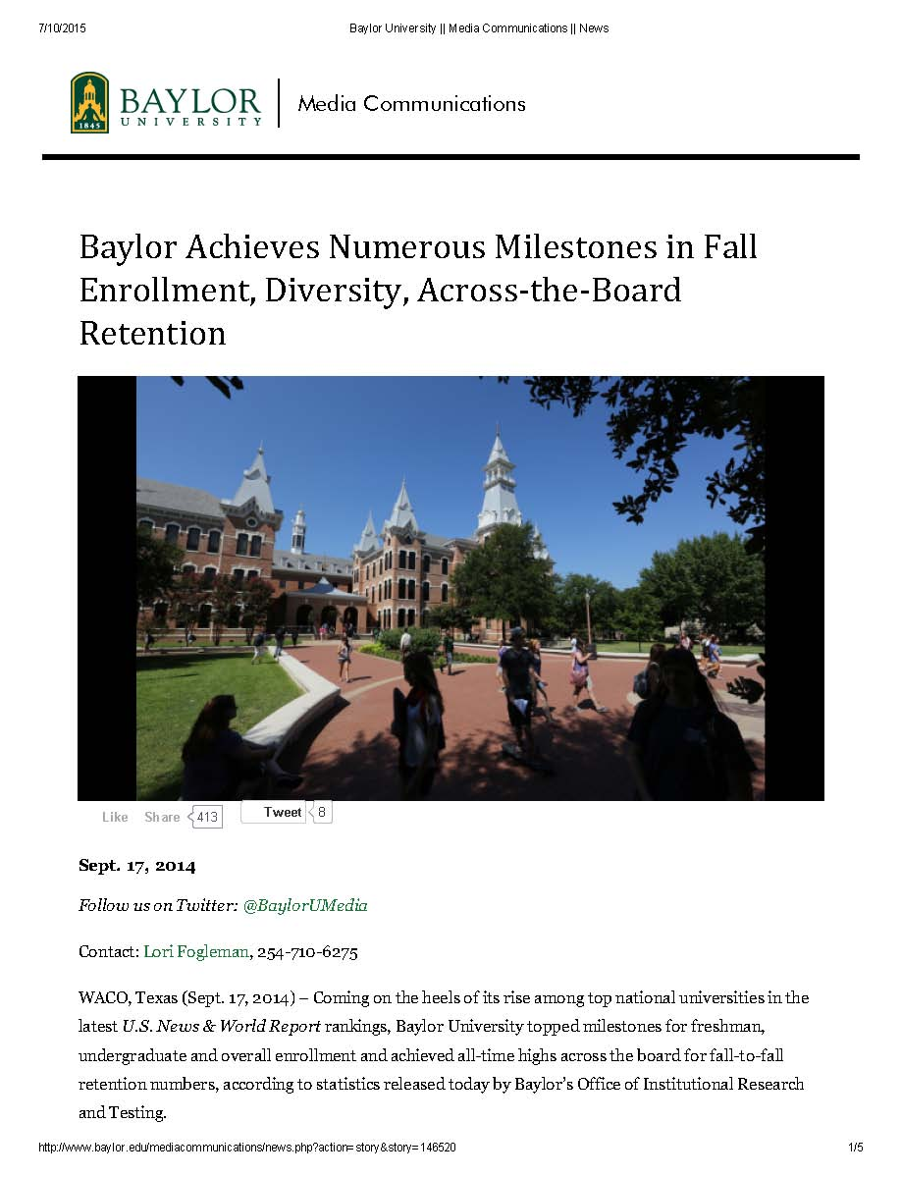

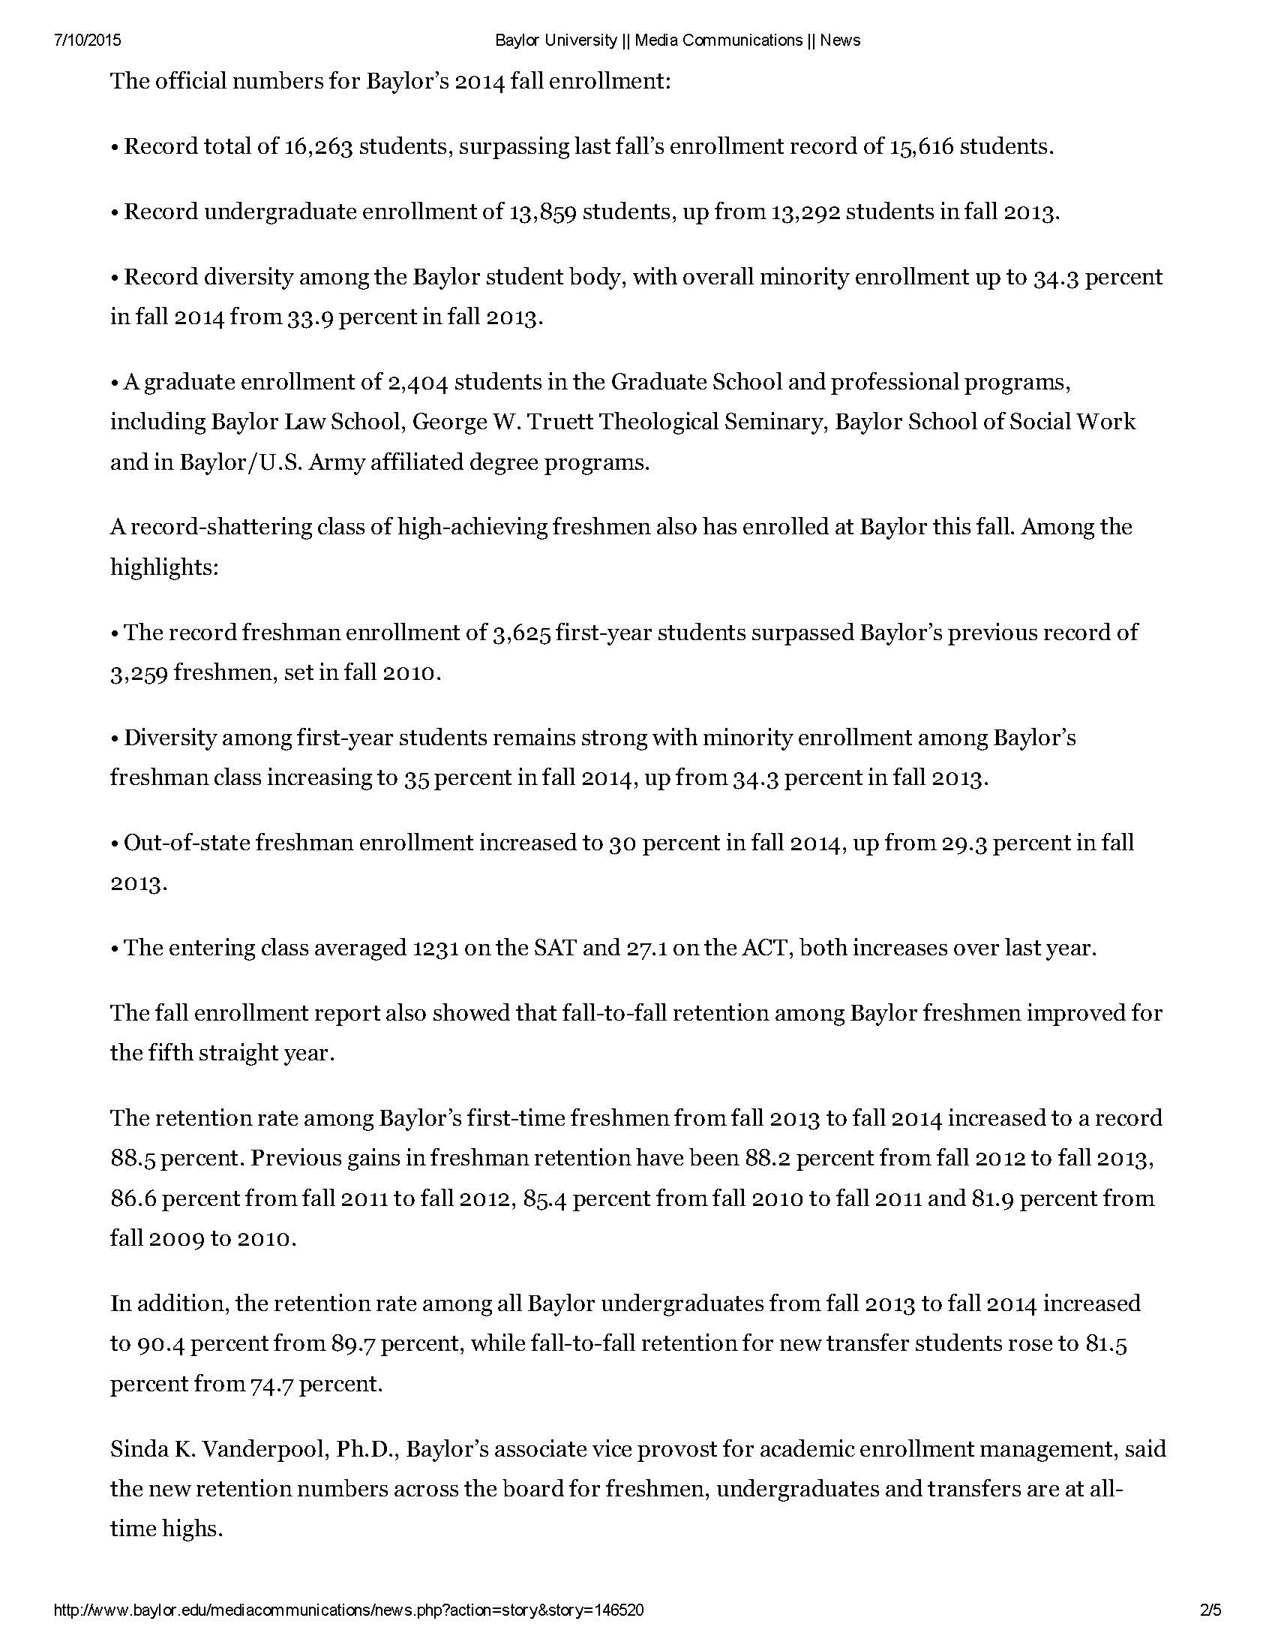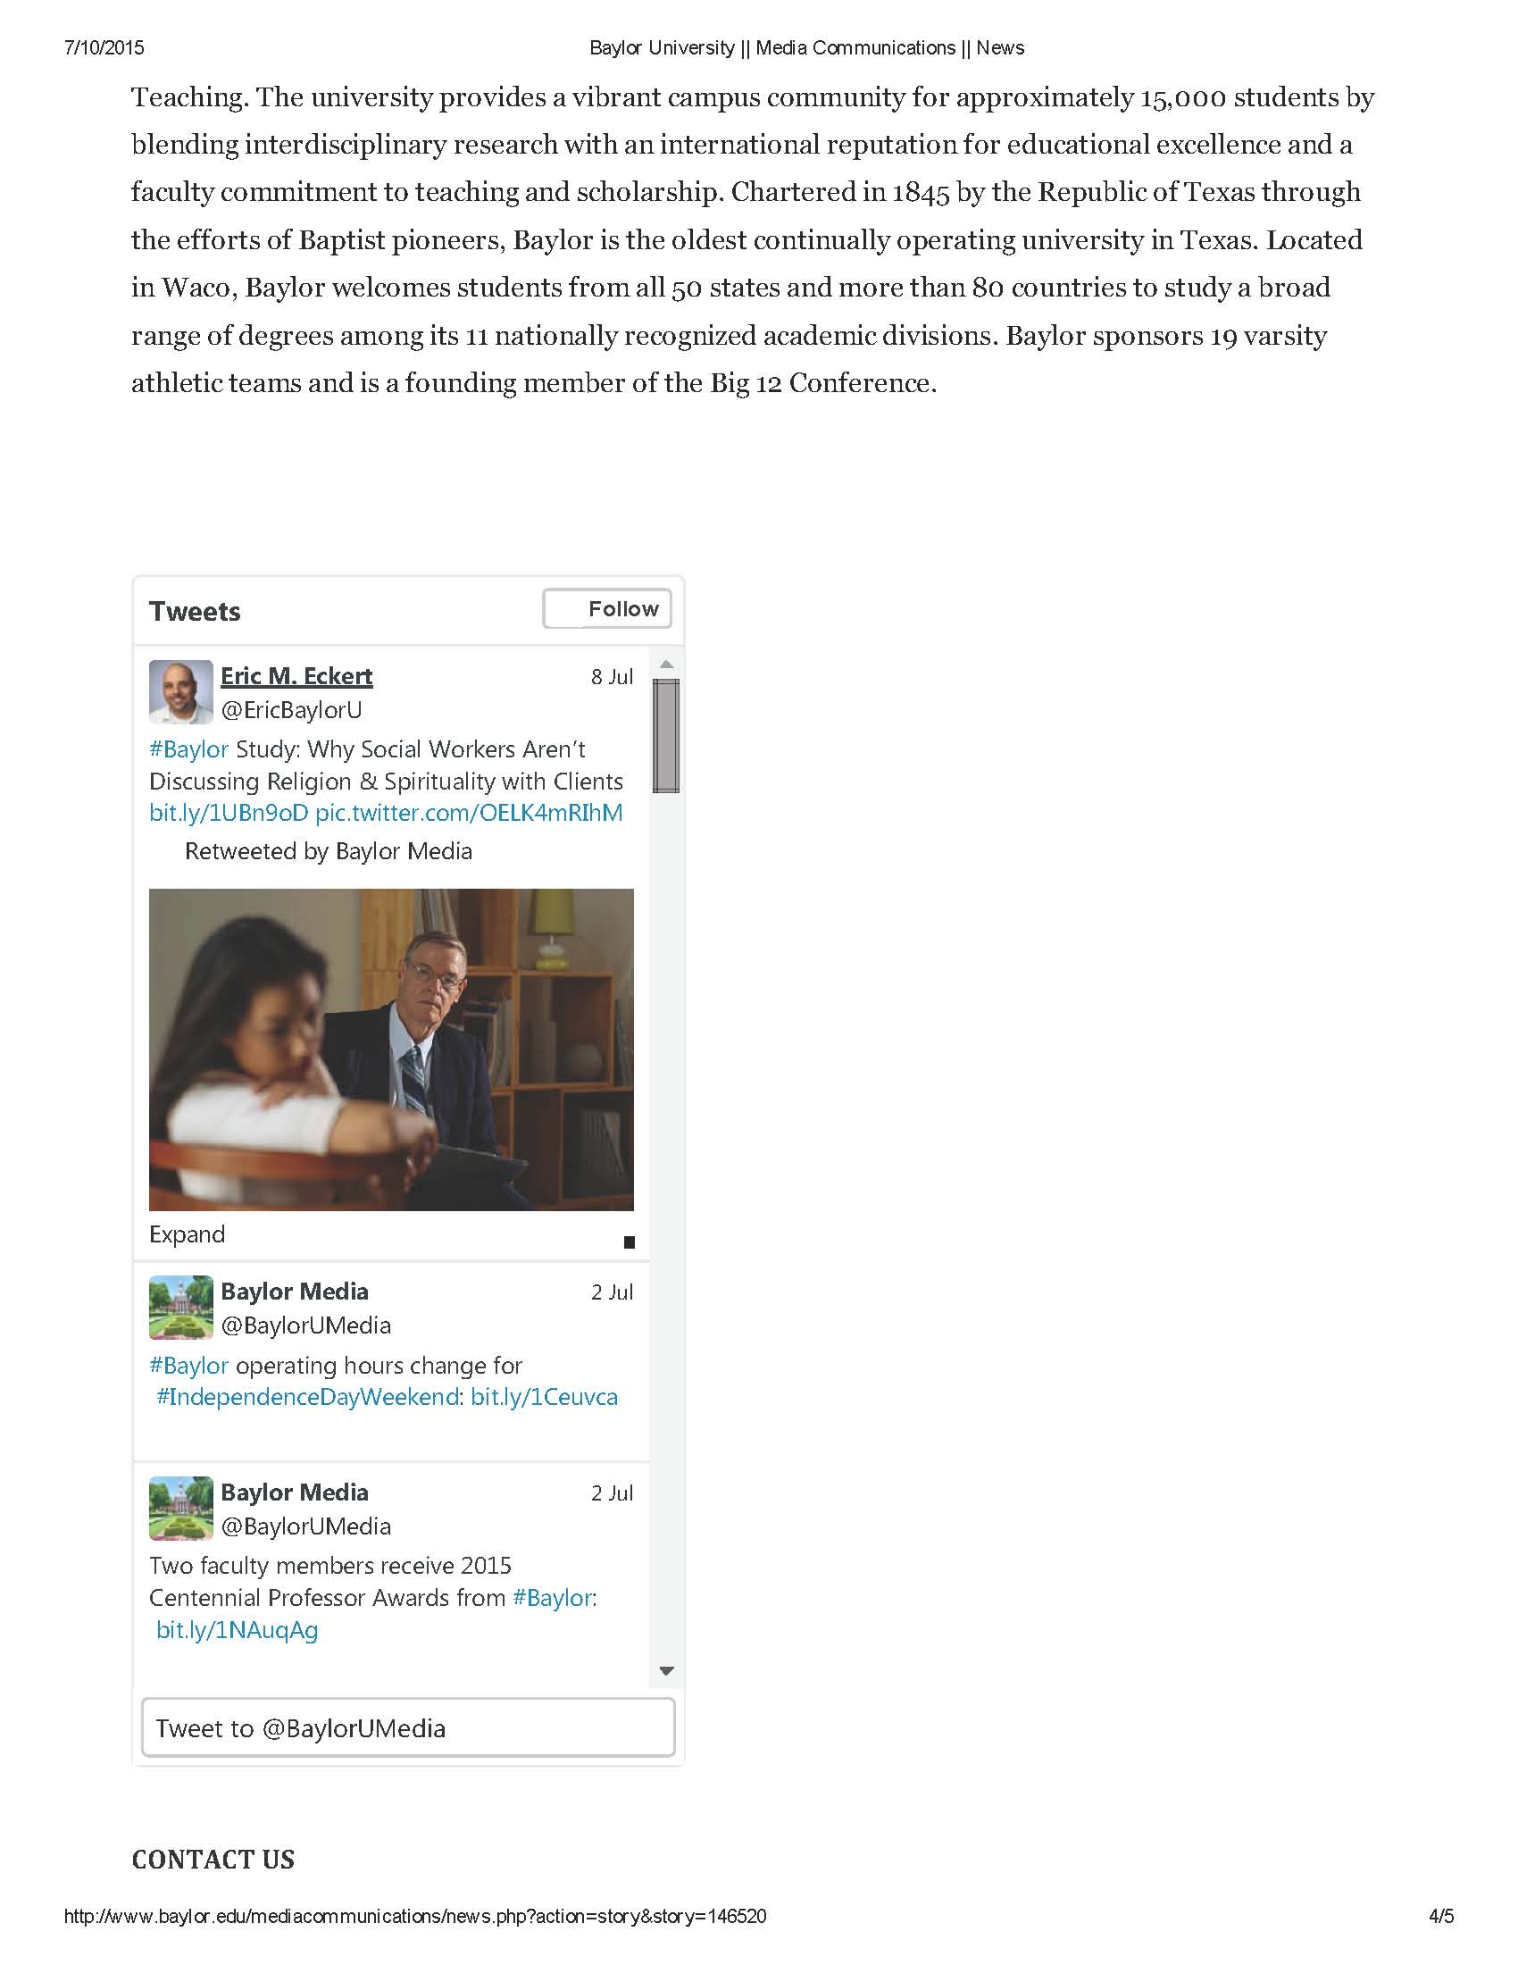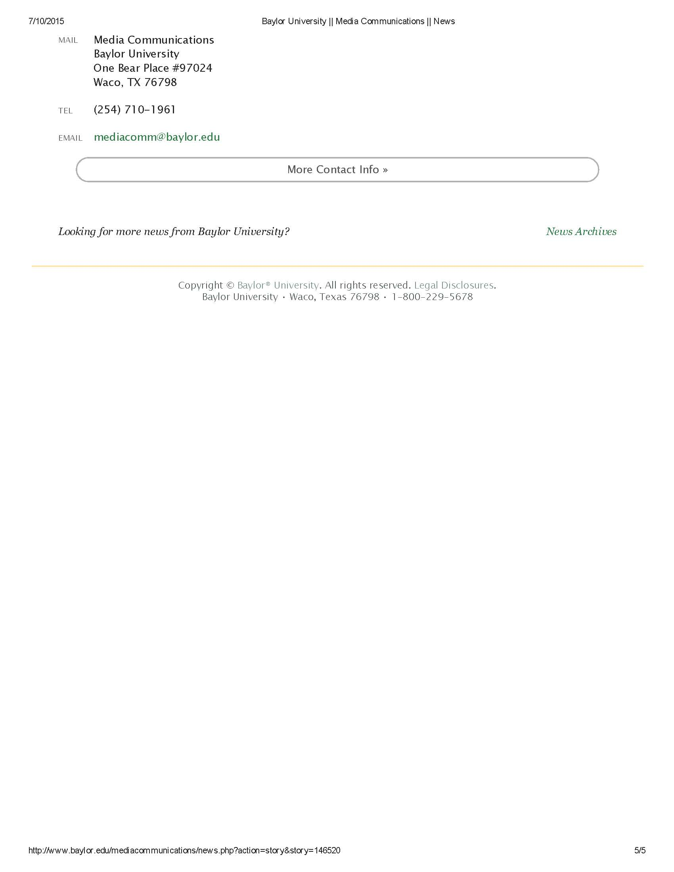

**Appendix B: benoit_ResearchPoster.pptx**

This is the flier/poster that will be handed out or placed to help with recruitment for this study. The recruitment poster was submitted alongside the protocol and can be found with other submitted materials.

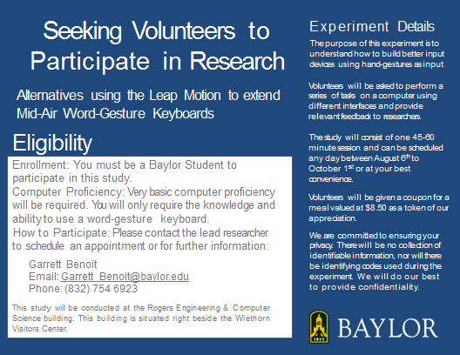

**Appendix C: benoit_ConsentForm.docx**

Consent form that all subjects must read and sign in order to participate in this study. The consent form was submitted alongside the protocol and can be found with other submitted materials.

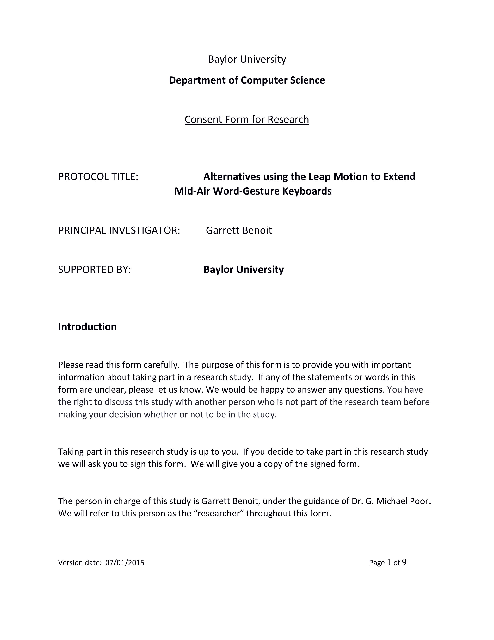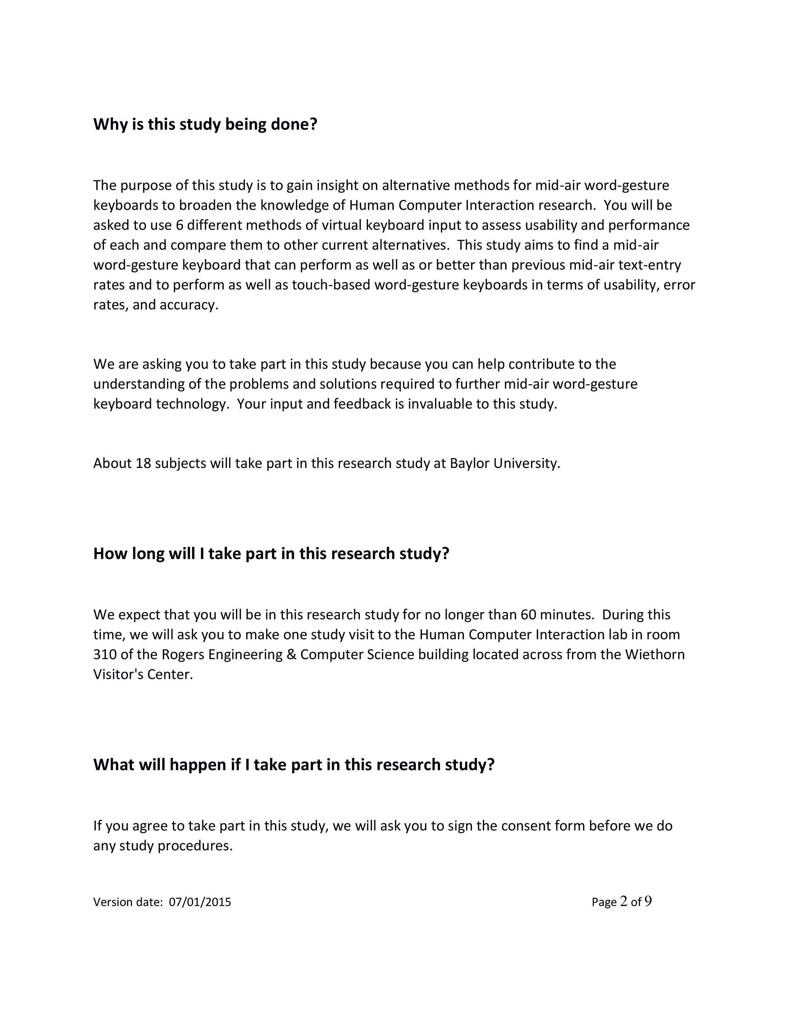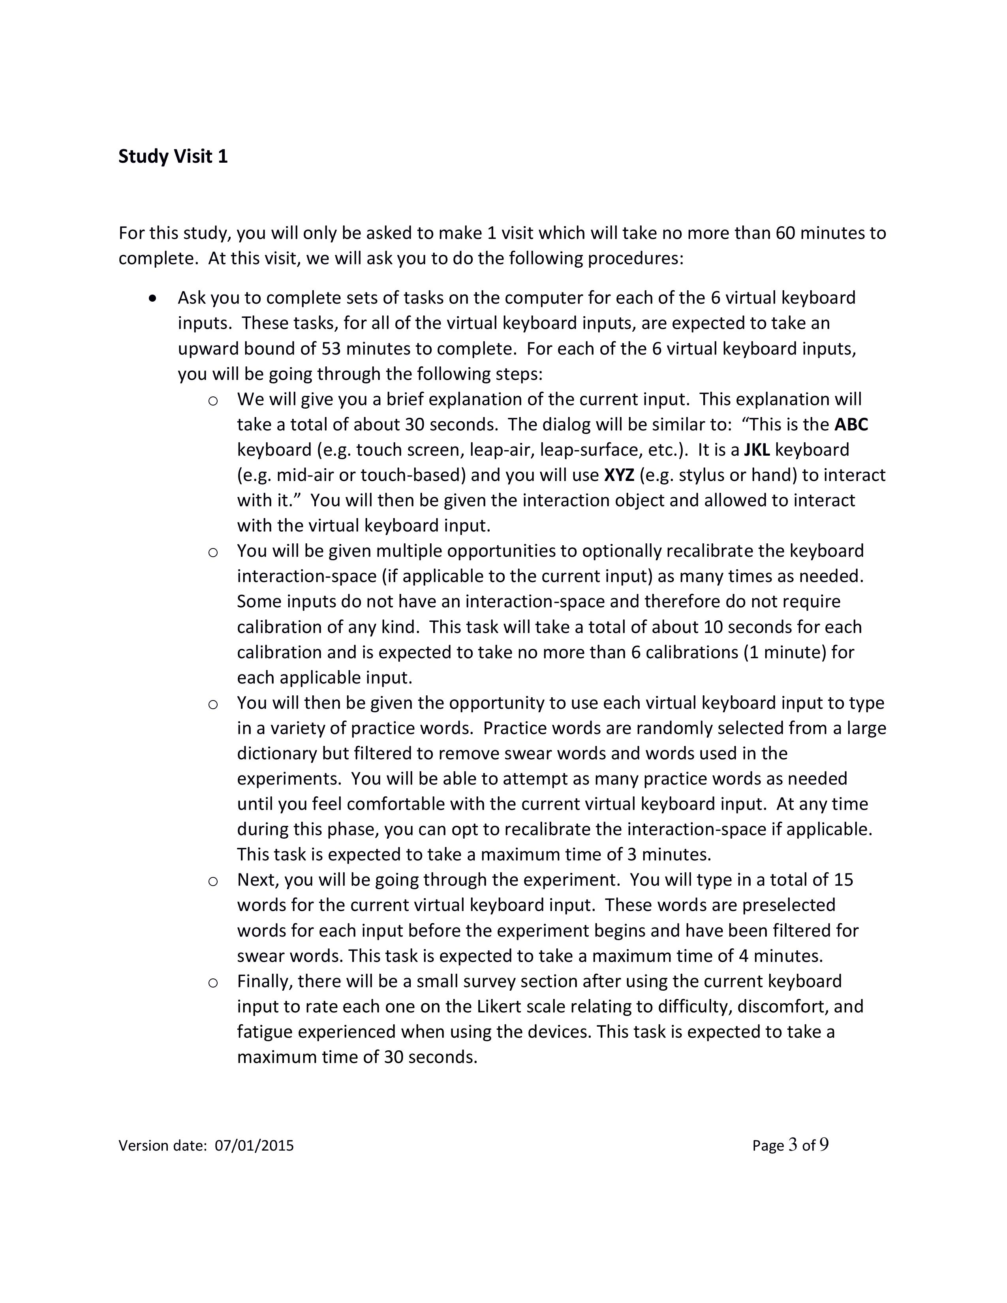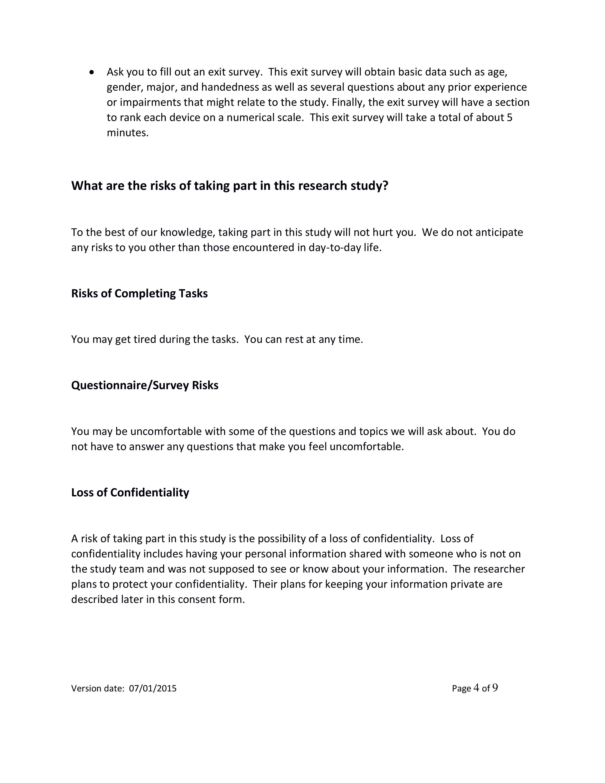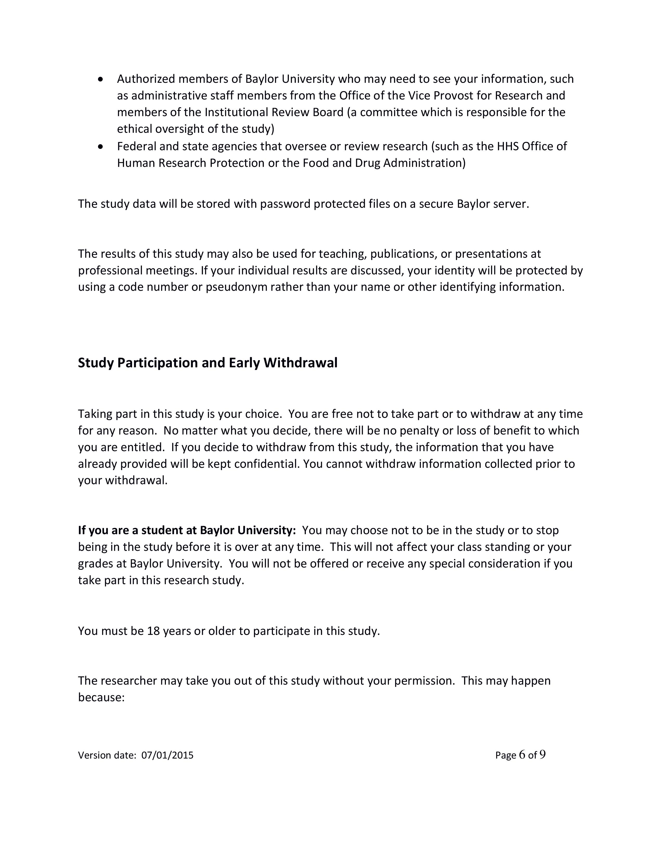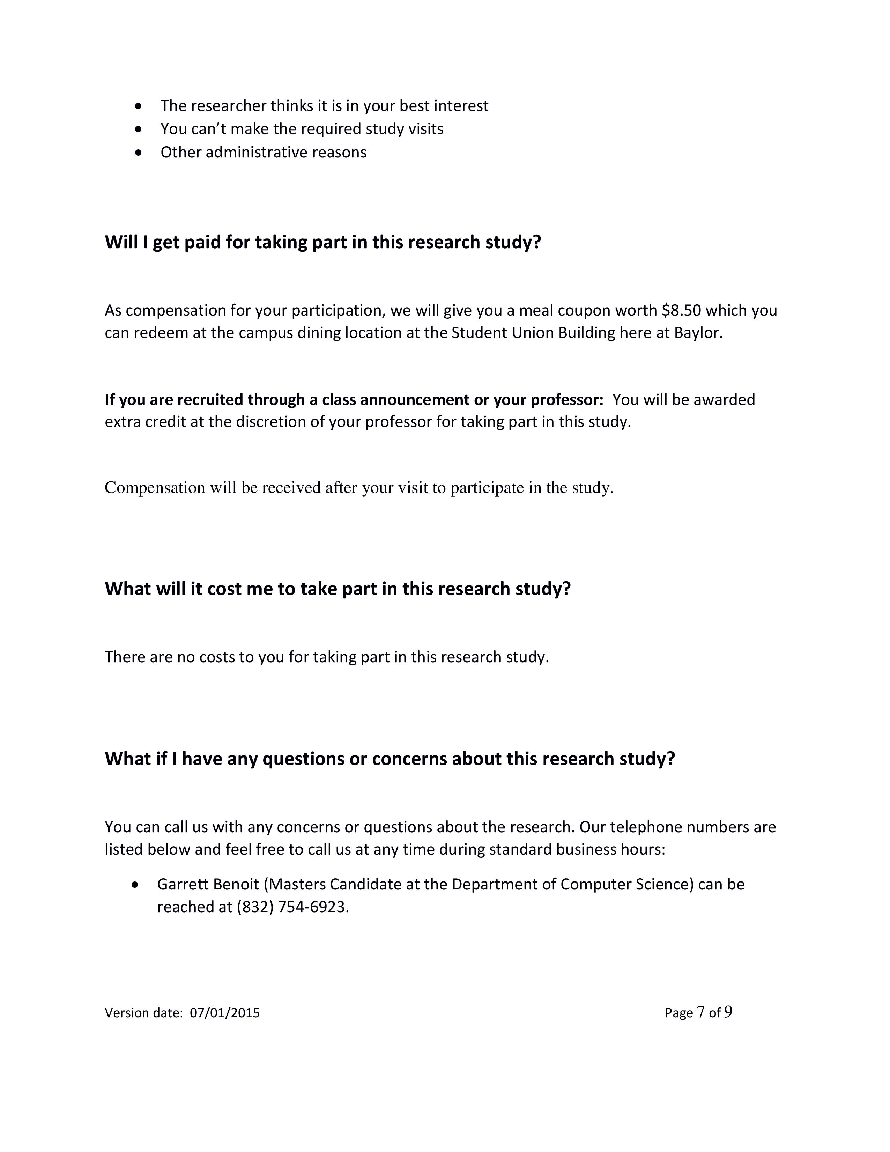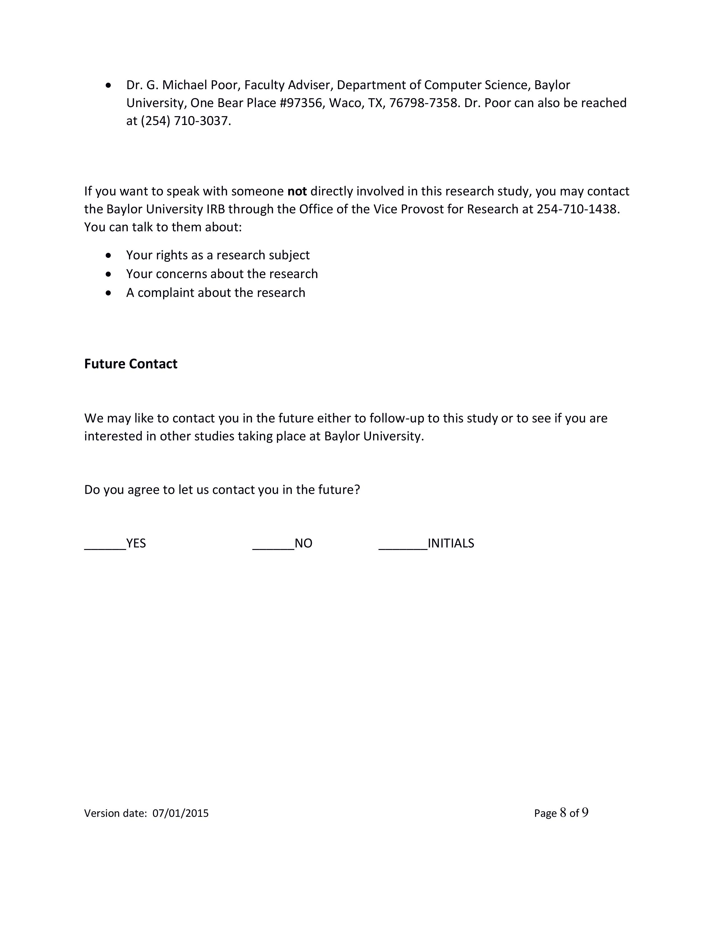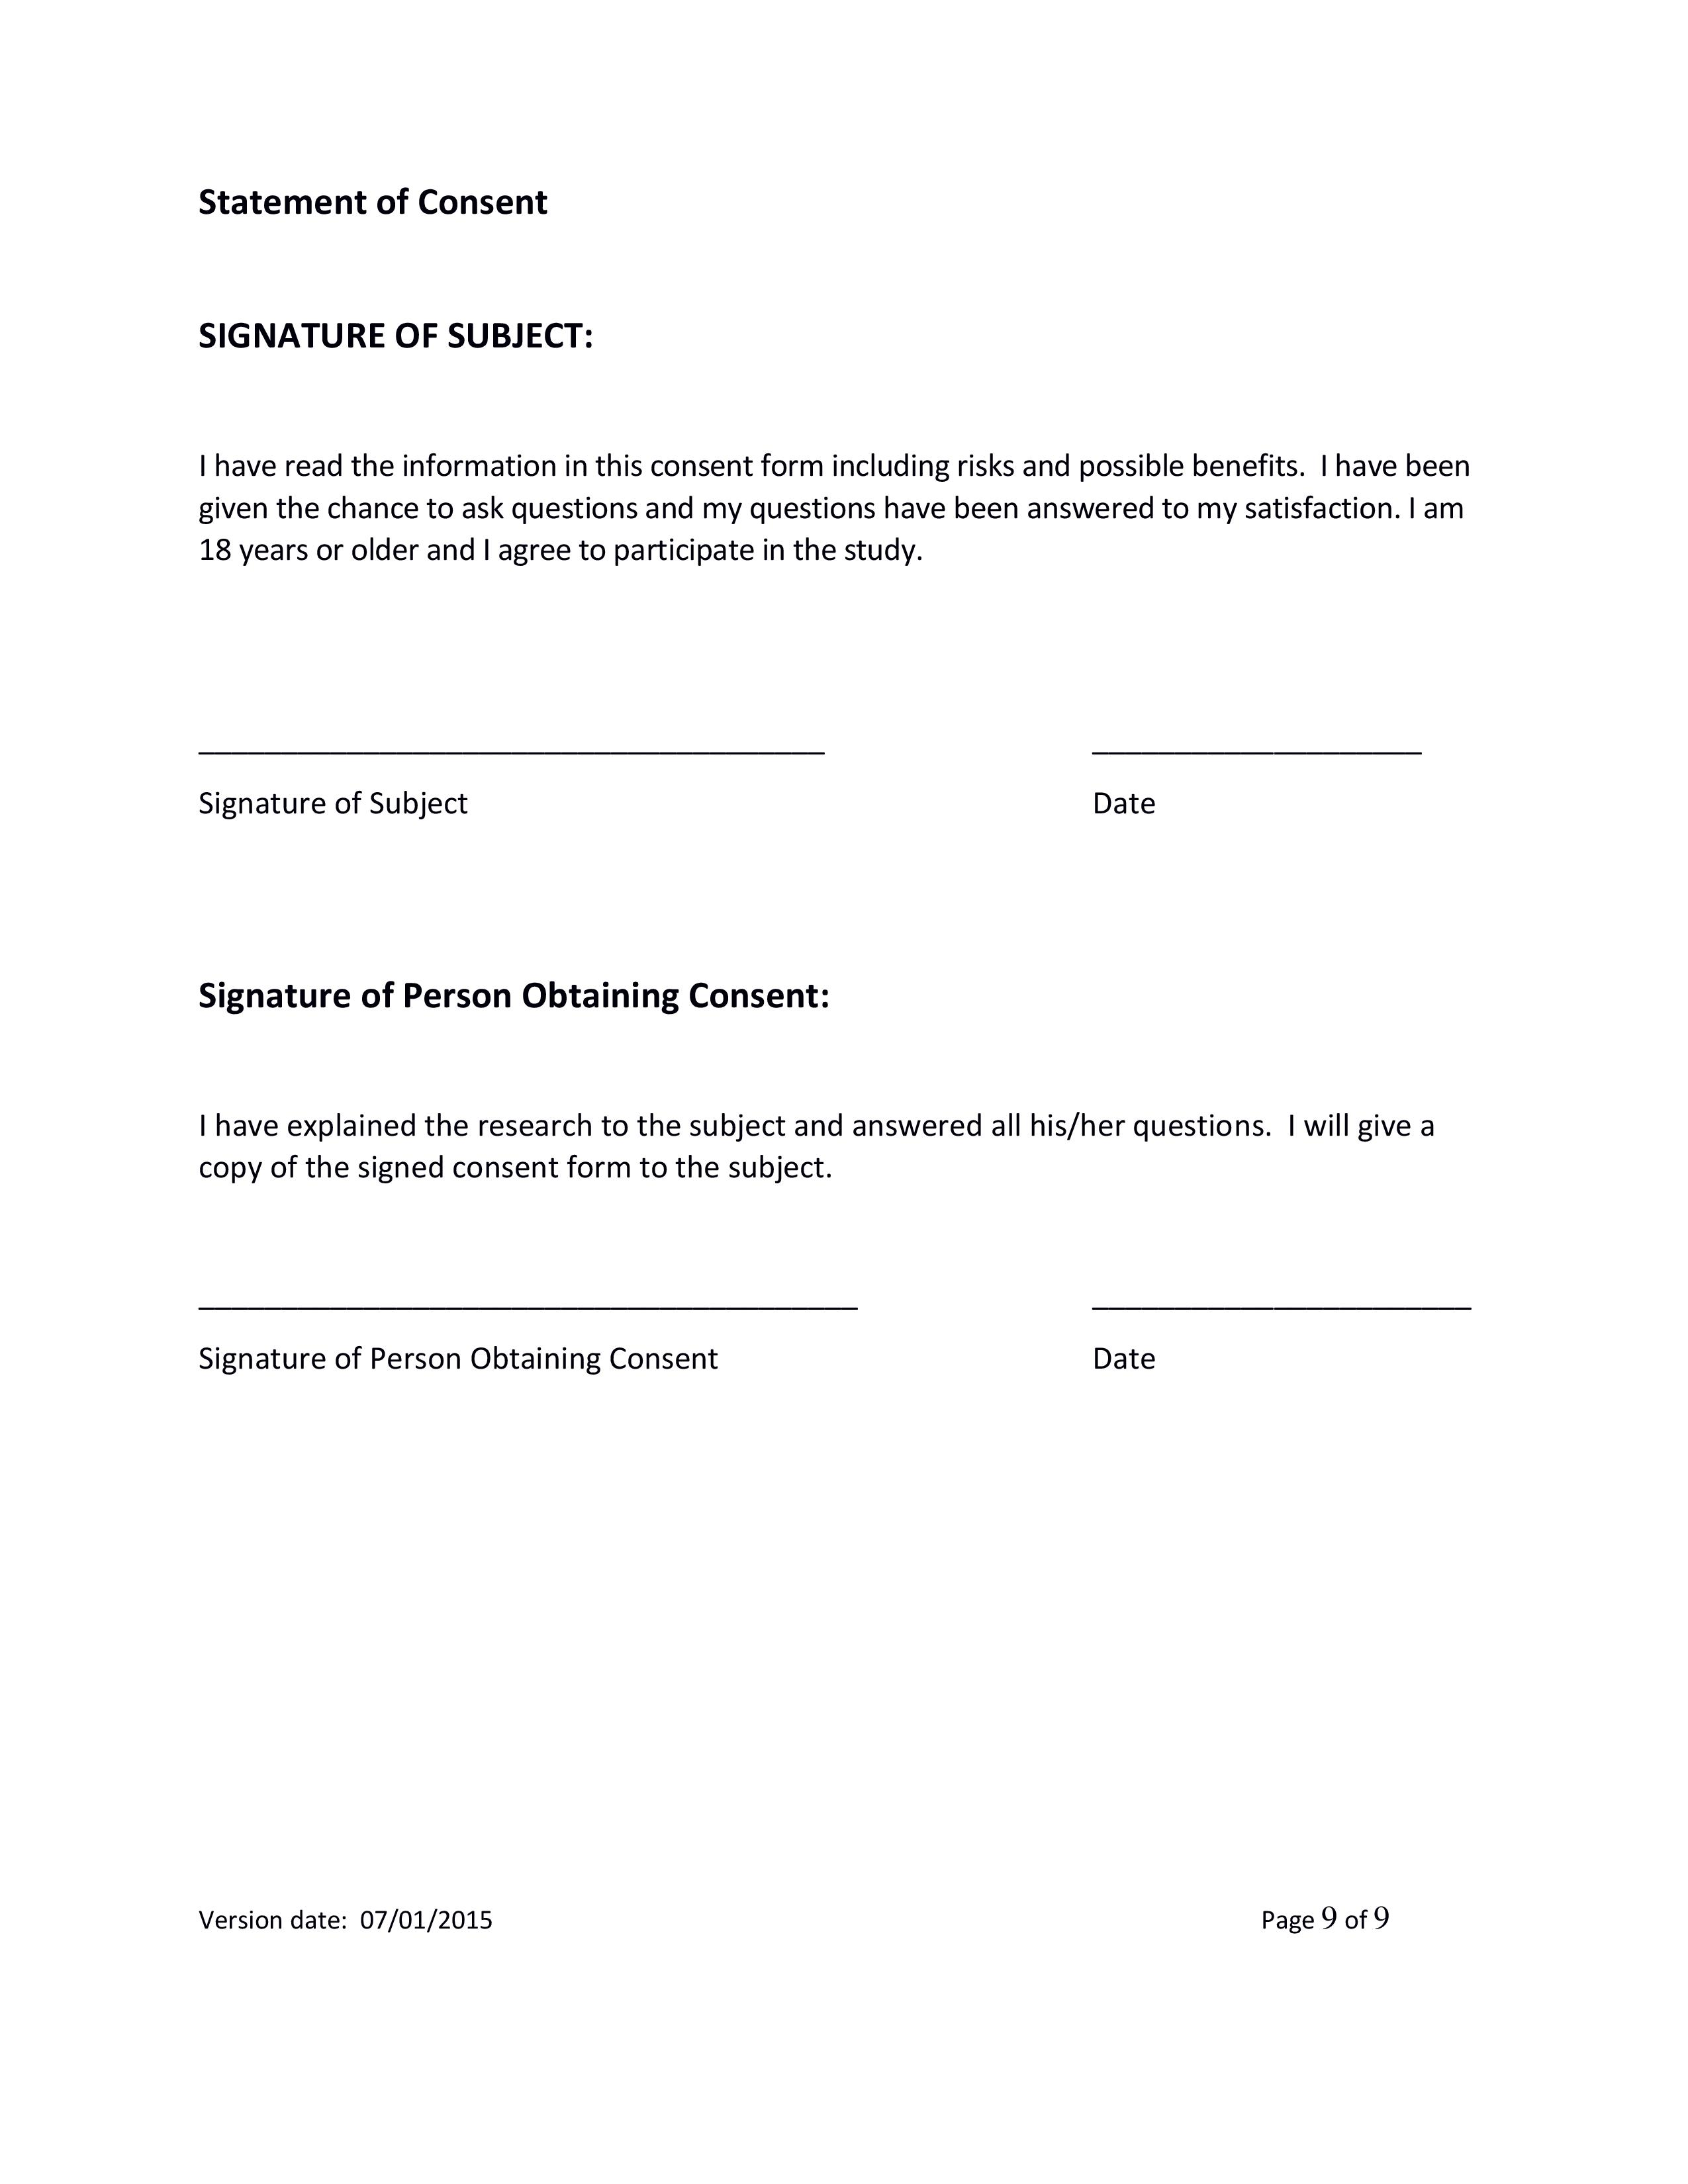

**Appendix D: benoit_ElectronicKeyboardSurveyExample.pdf**

Example of the short survey the subject will have to fill out after using each input method. These surveys use the Likert scale regarding discomfort experienced, difficulty using the device, and fatigue experienced for that particular input method. This document contains an example of the Leap Motion, dynamic keyboard survey. The surveys will all be the same but will have the appropriate keyboard name listed instead. The surveys are submitted and recorded electronically by the software. The example keyboard survey was submitted alongside the protocol and can be found with other submitted materials.

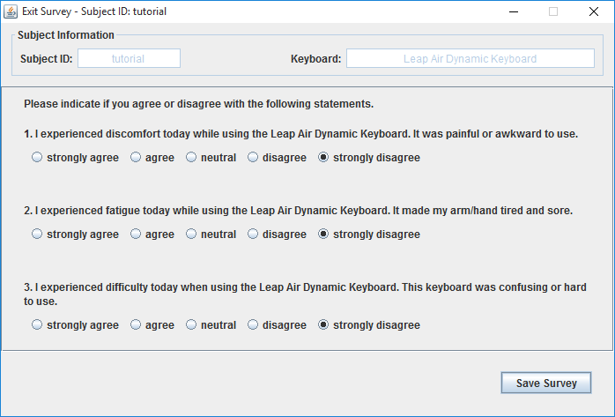

**Appendix E: benoit_ElectronicExitSurvey.pdf**

Example of the exit survey at the very end of the study visit. This exit survey consists of questions about the person and their experiences and a ranking system for the different input methods. The survey is submitted and recorded electronically by the software. The exit survey was submitted alongside the protocol and can be found with other submitted materials.

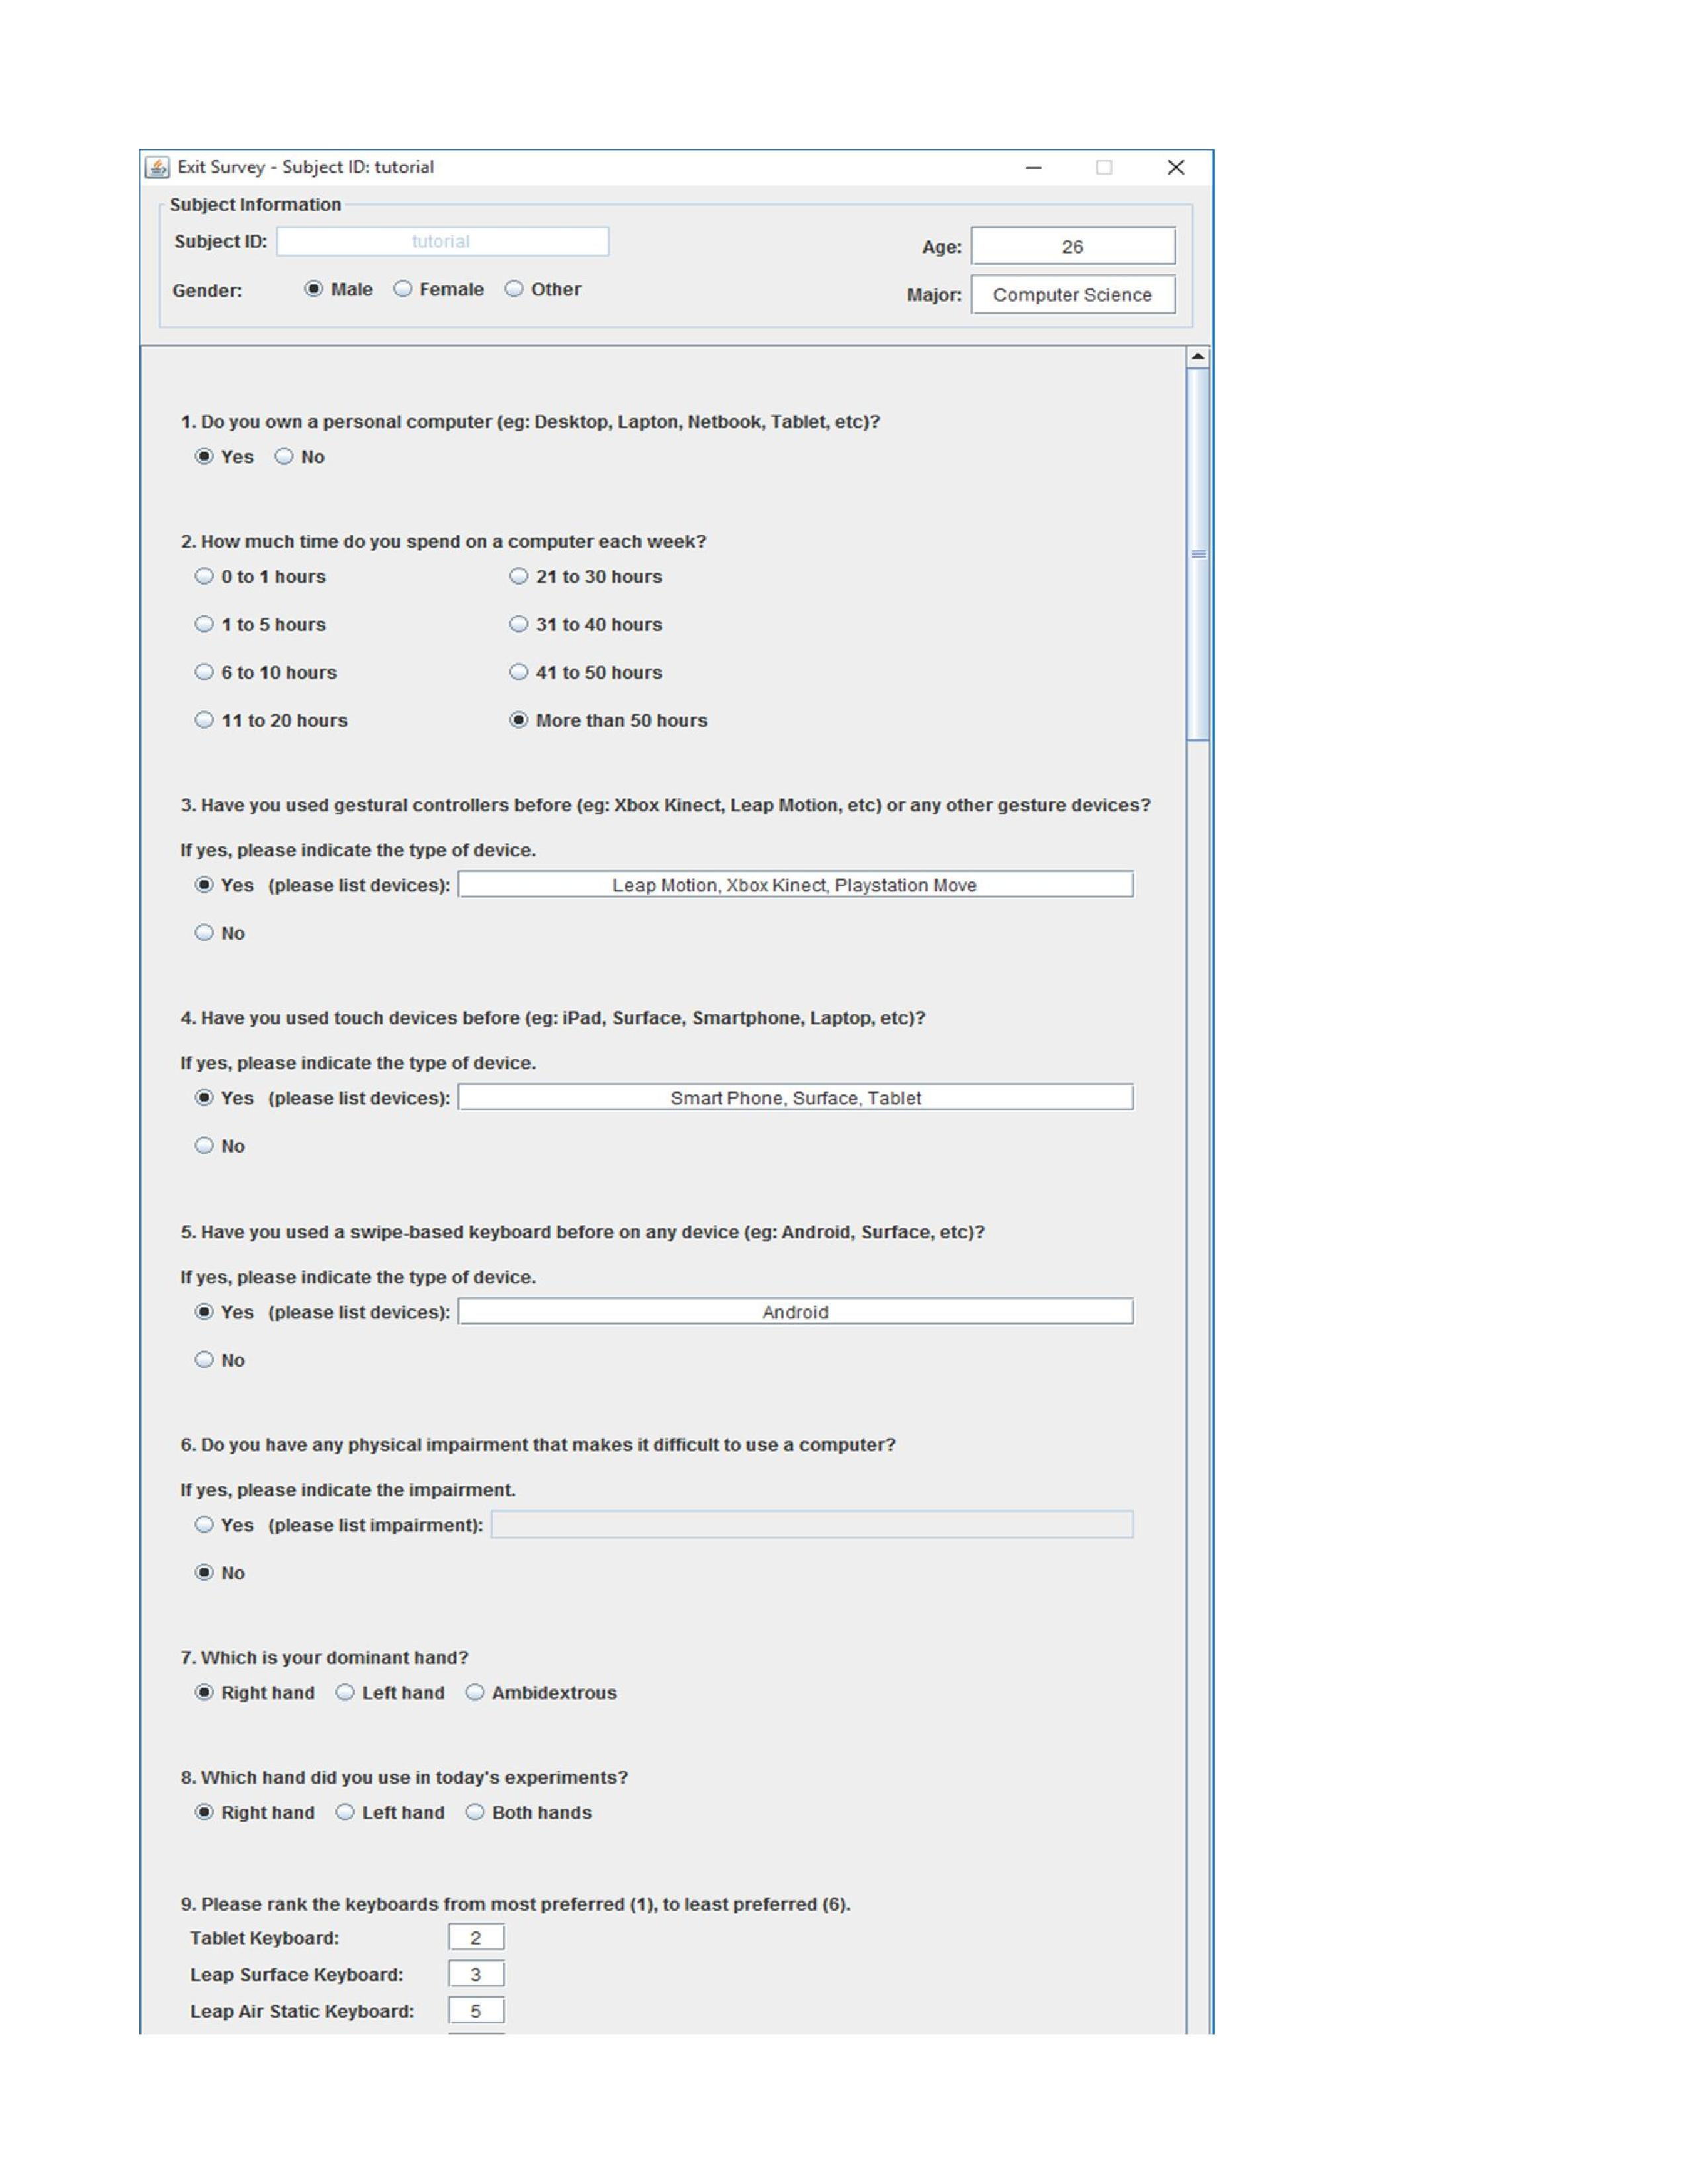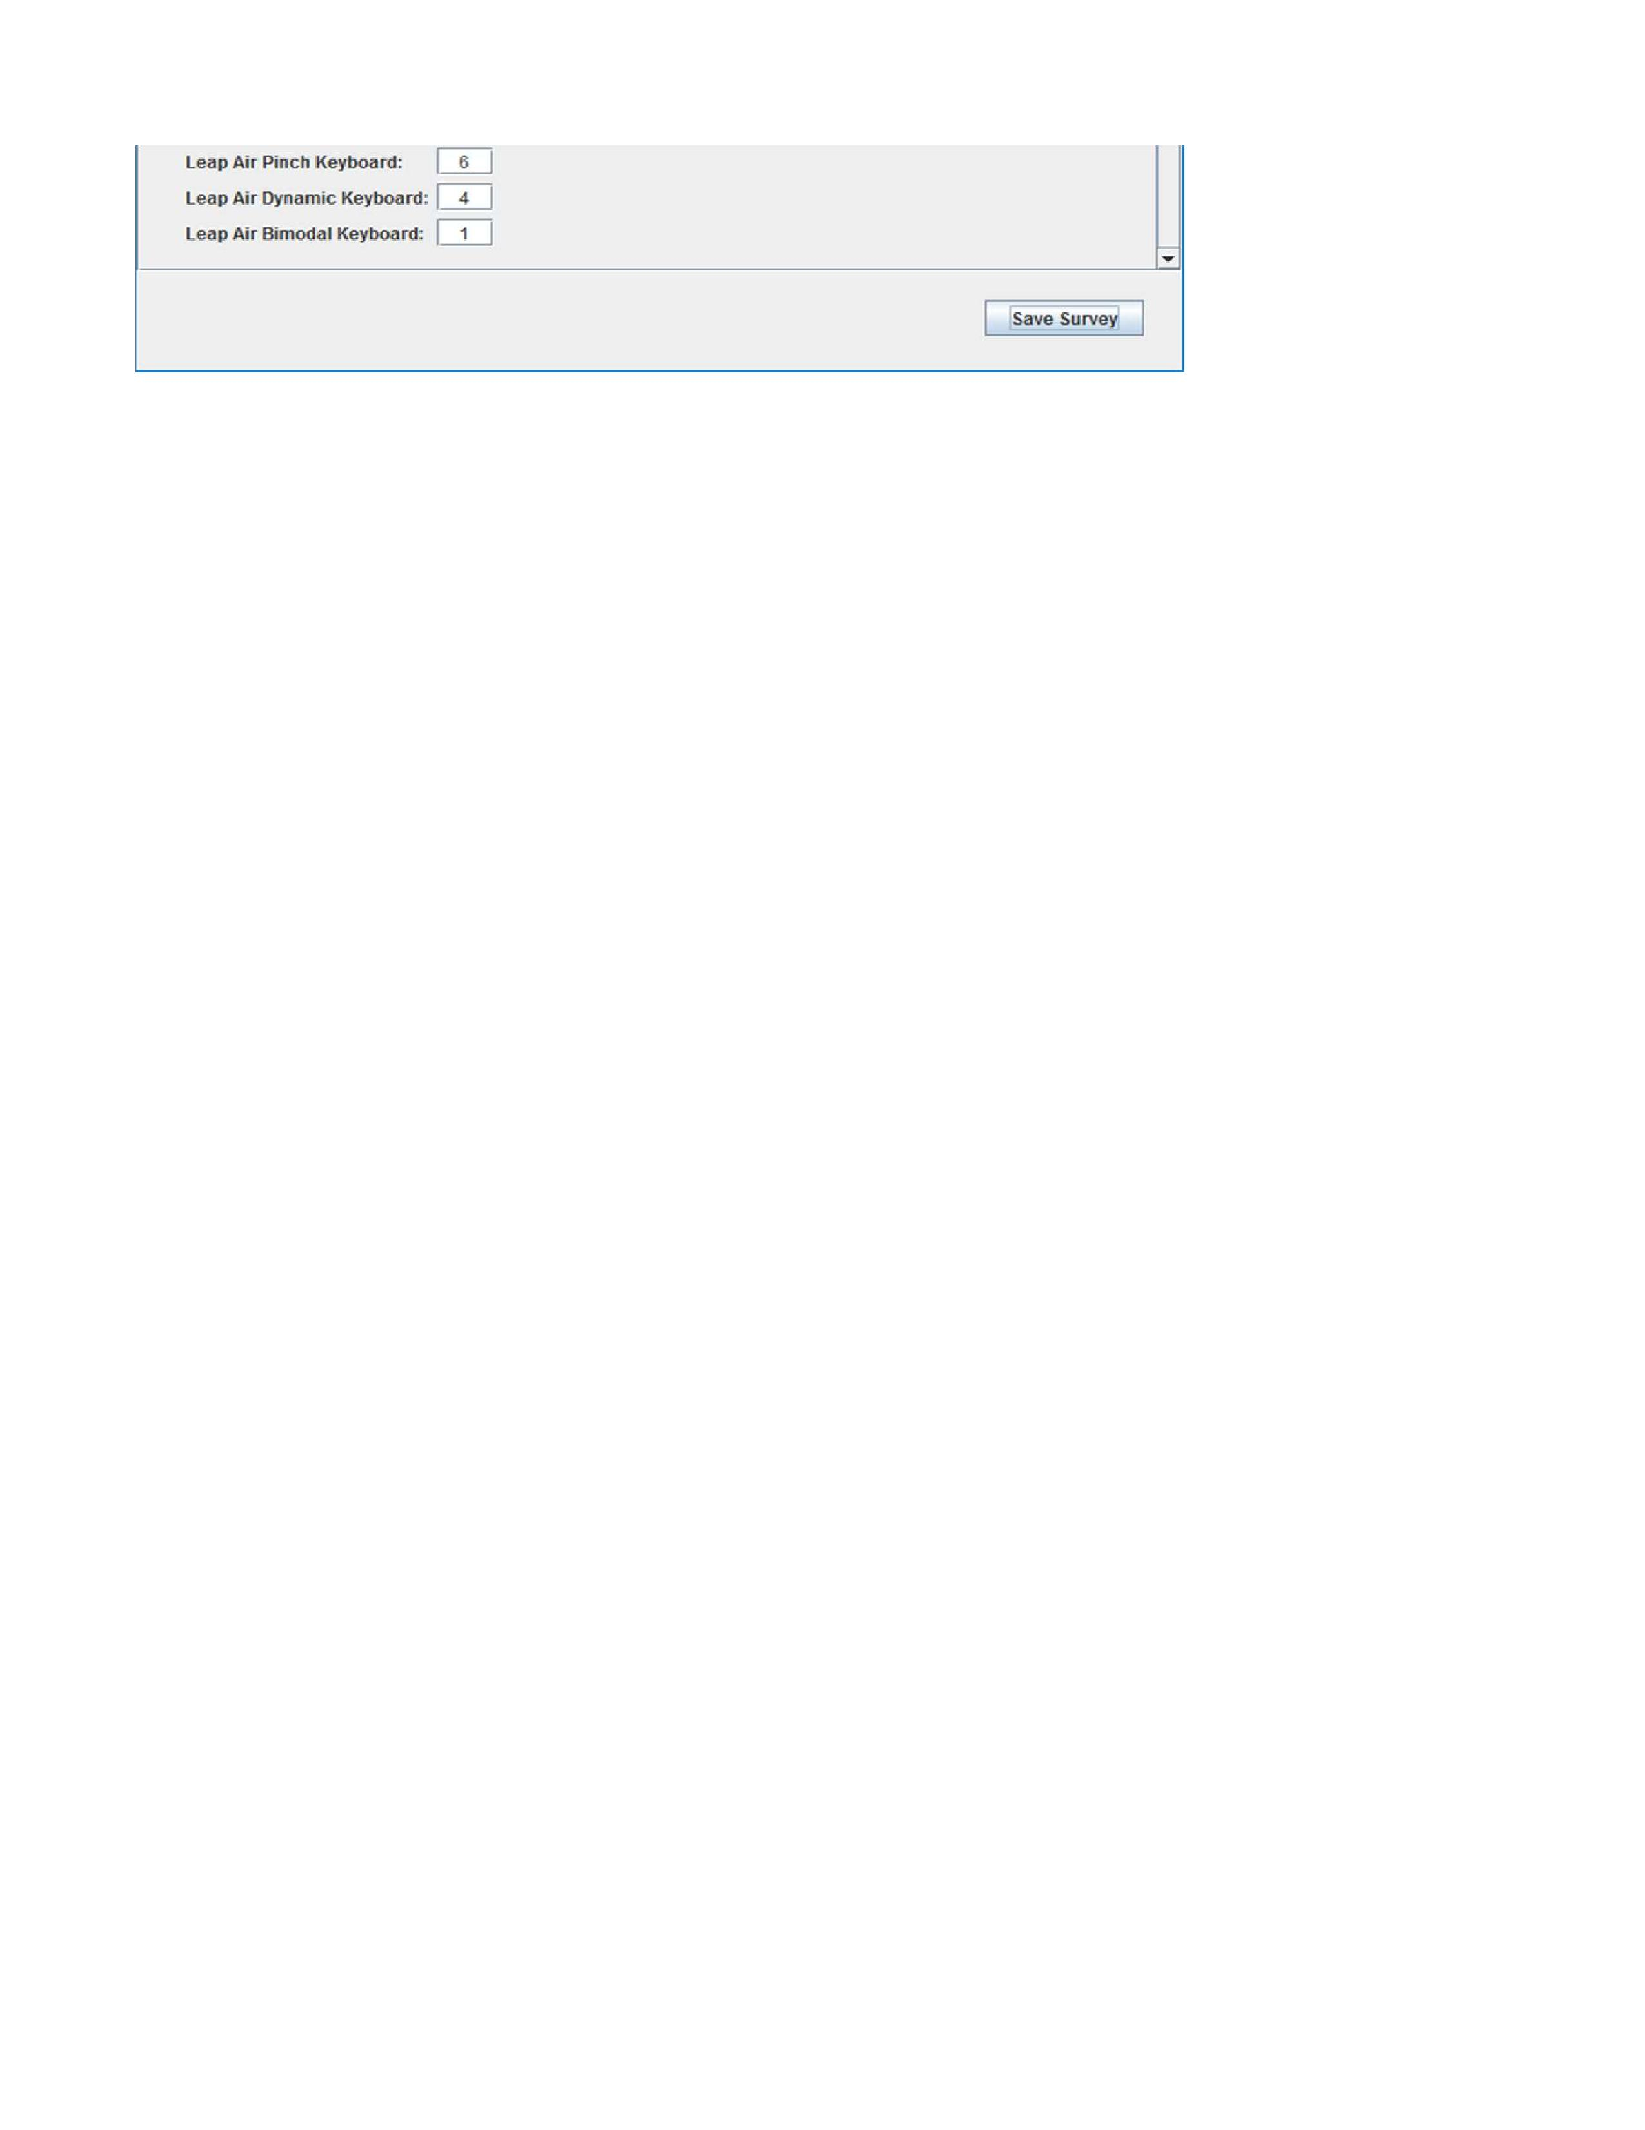

**Appendix F: benoit_DataCollectionSheet (Pilot).pdf**

Example of the data collection sheets that are generated by the software. The data collection sheets were submitted alongside the protocol and can be found with other submitted materials.

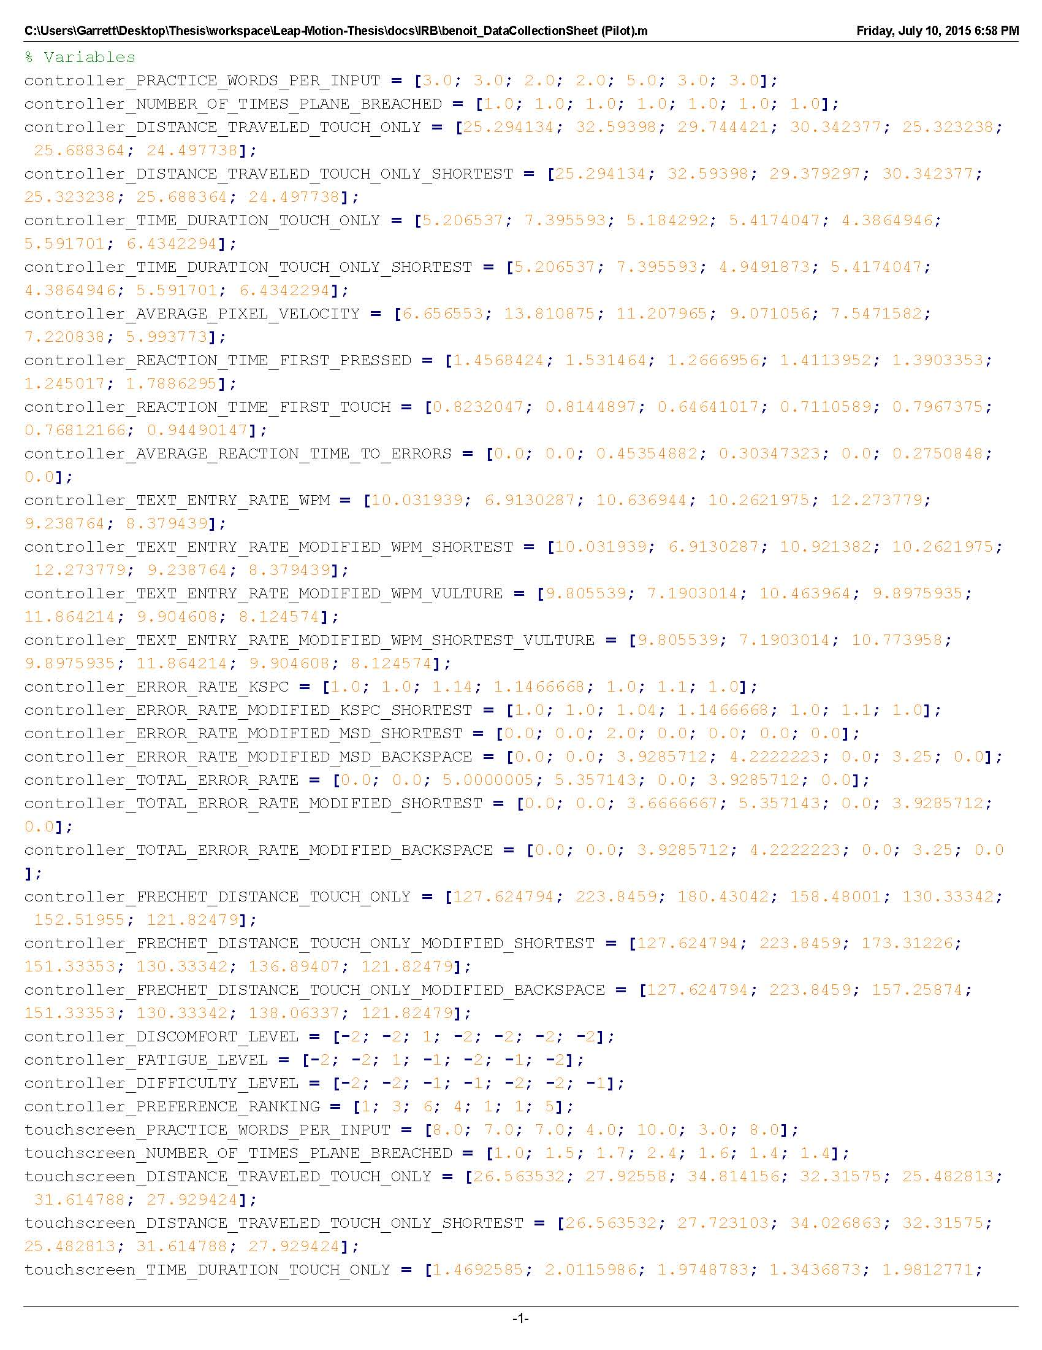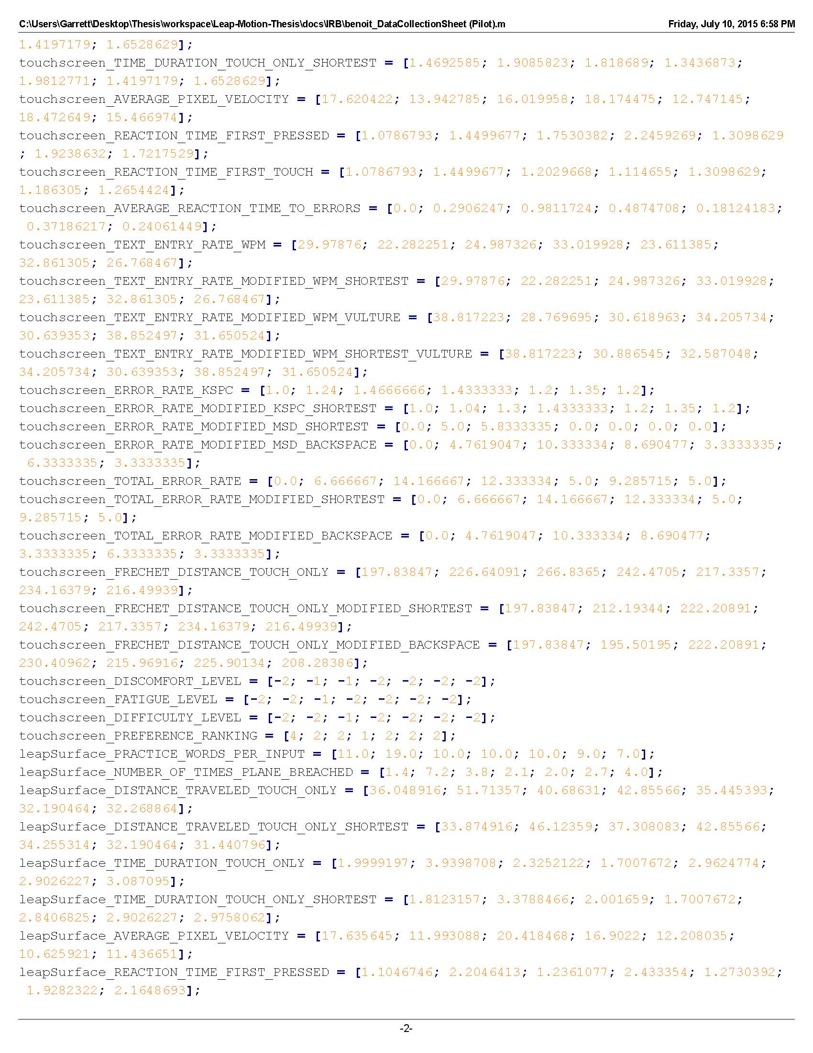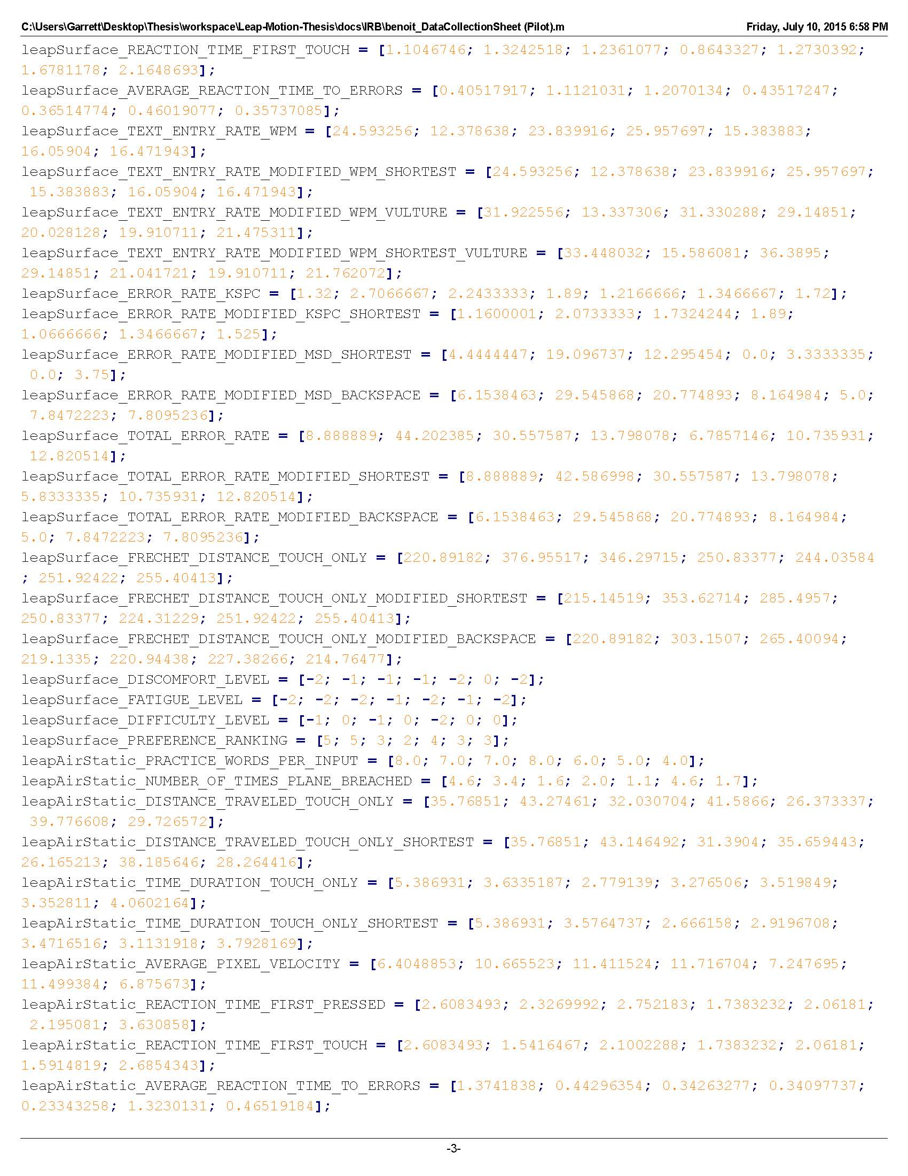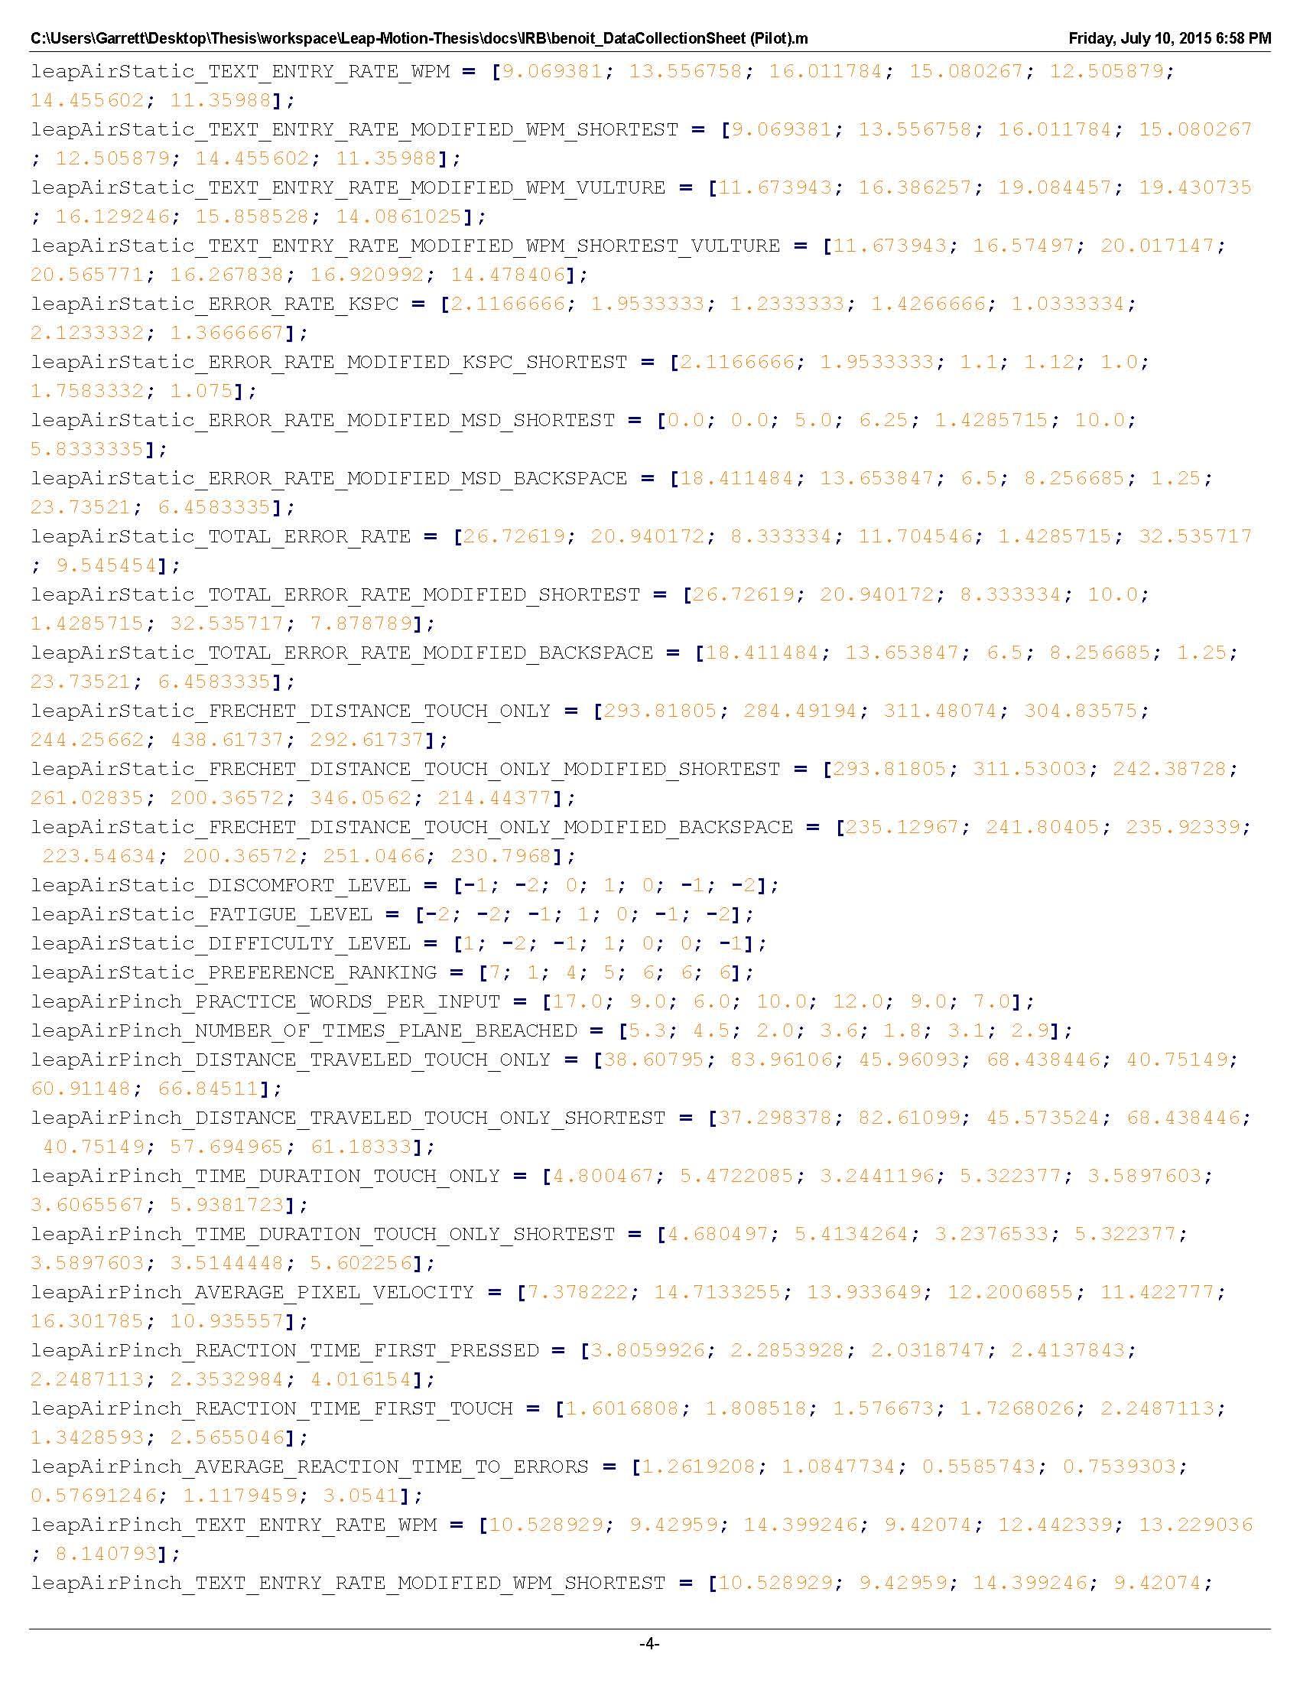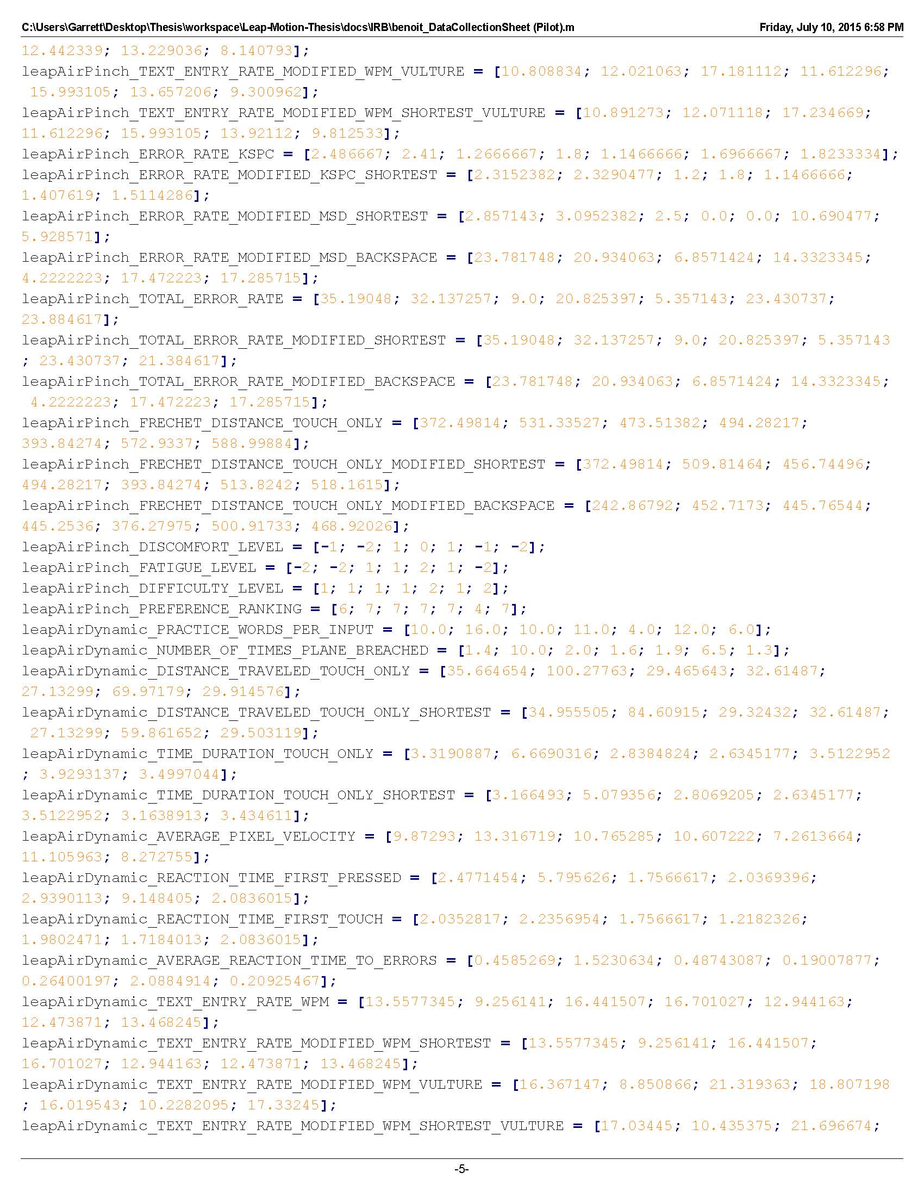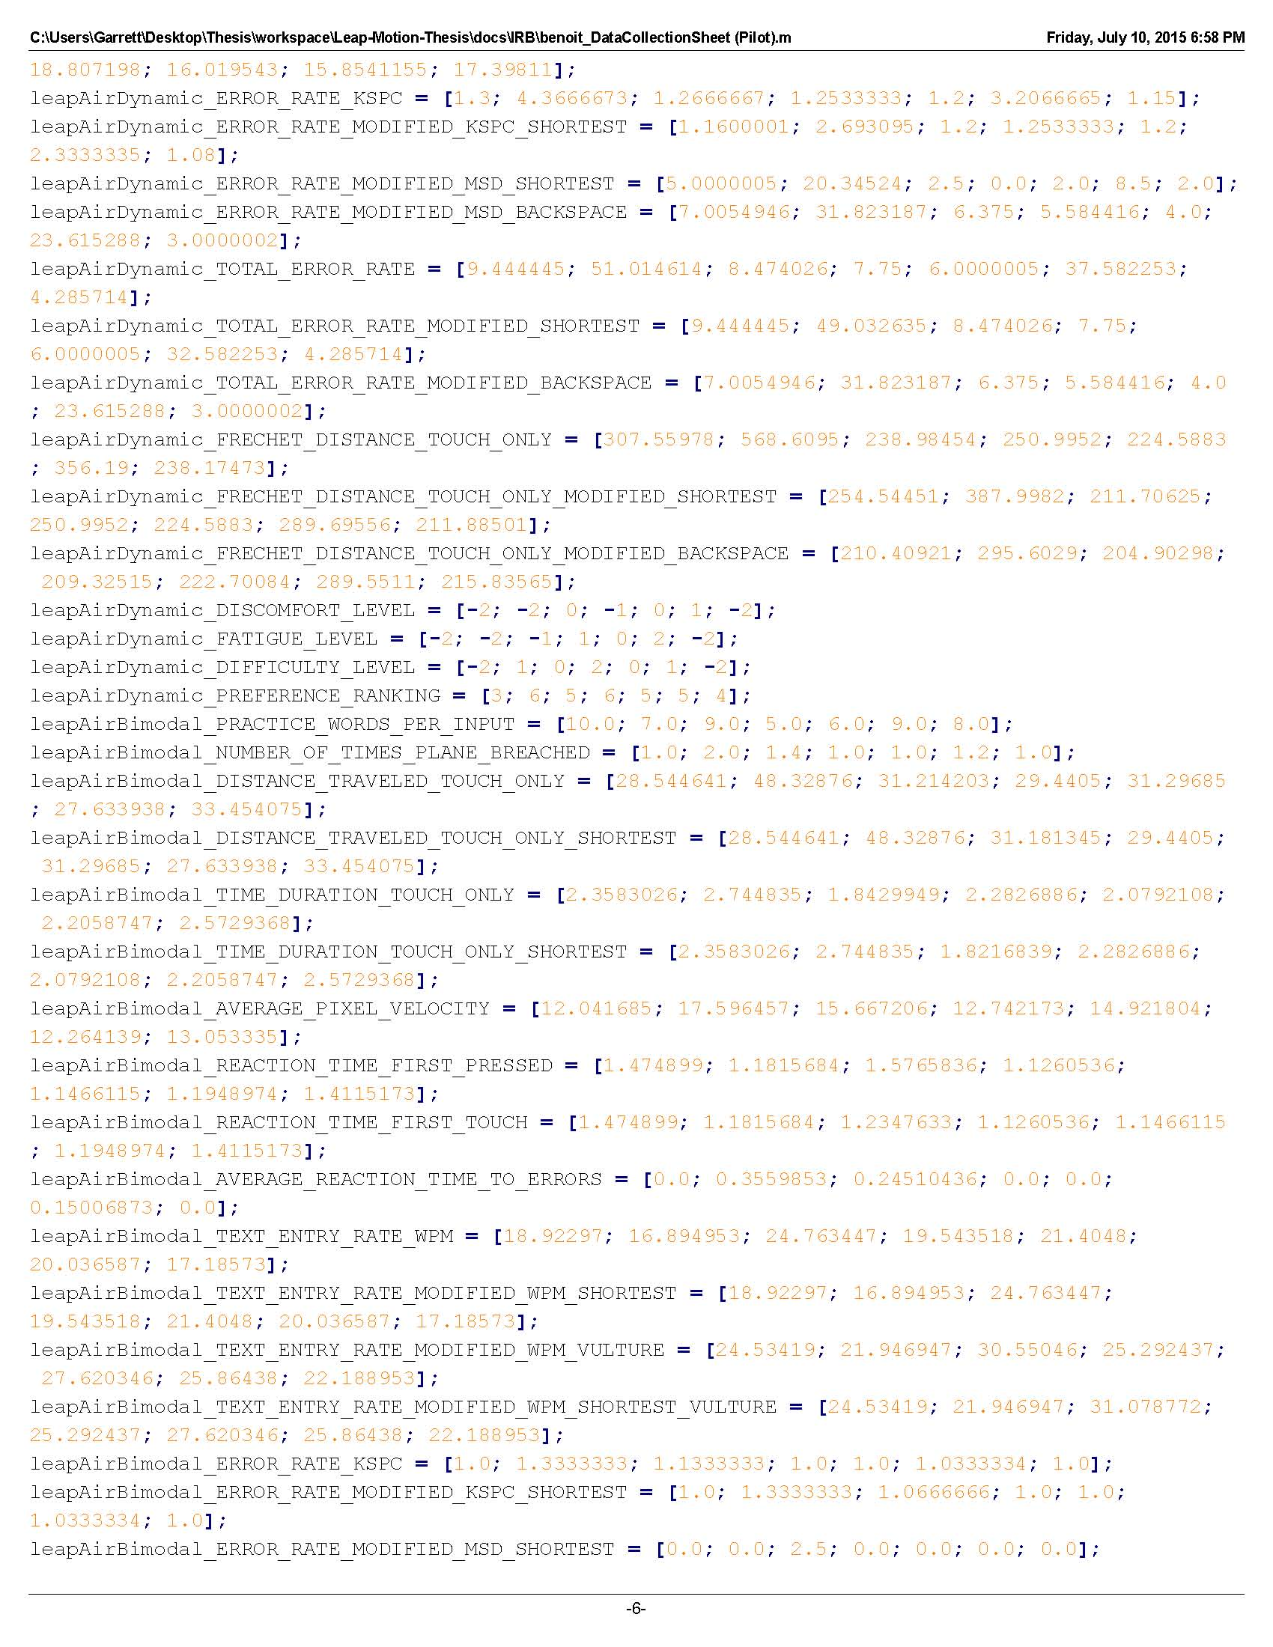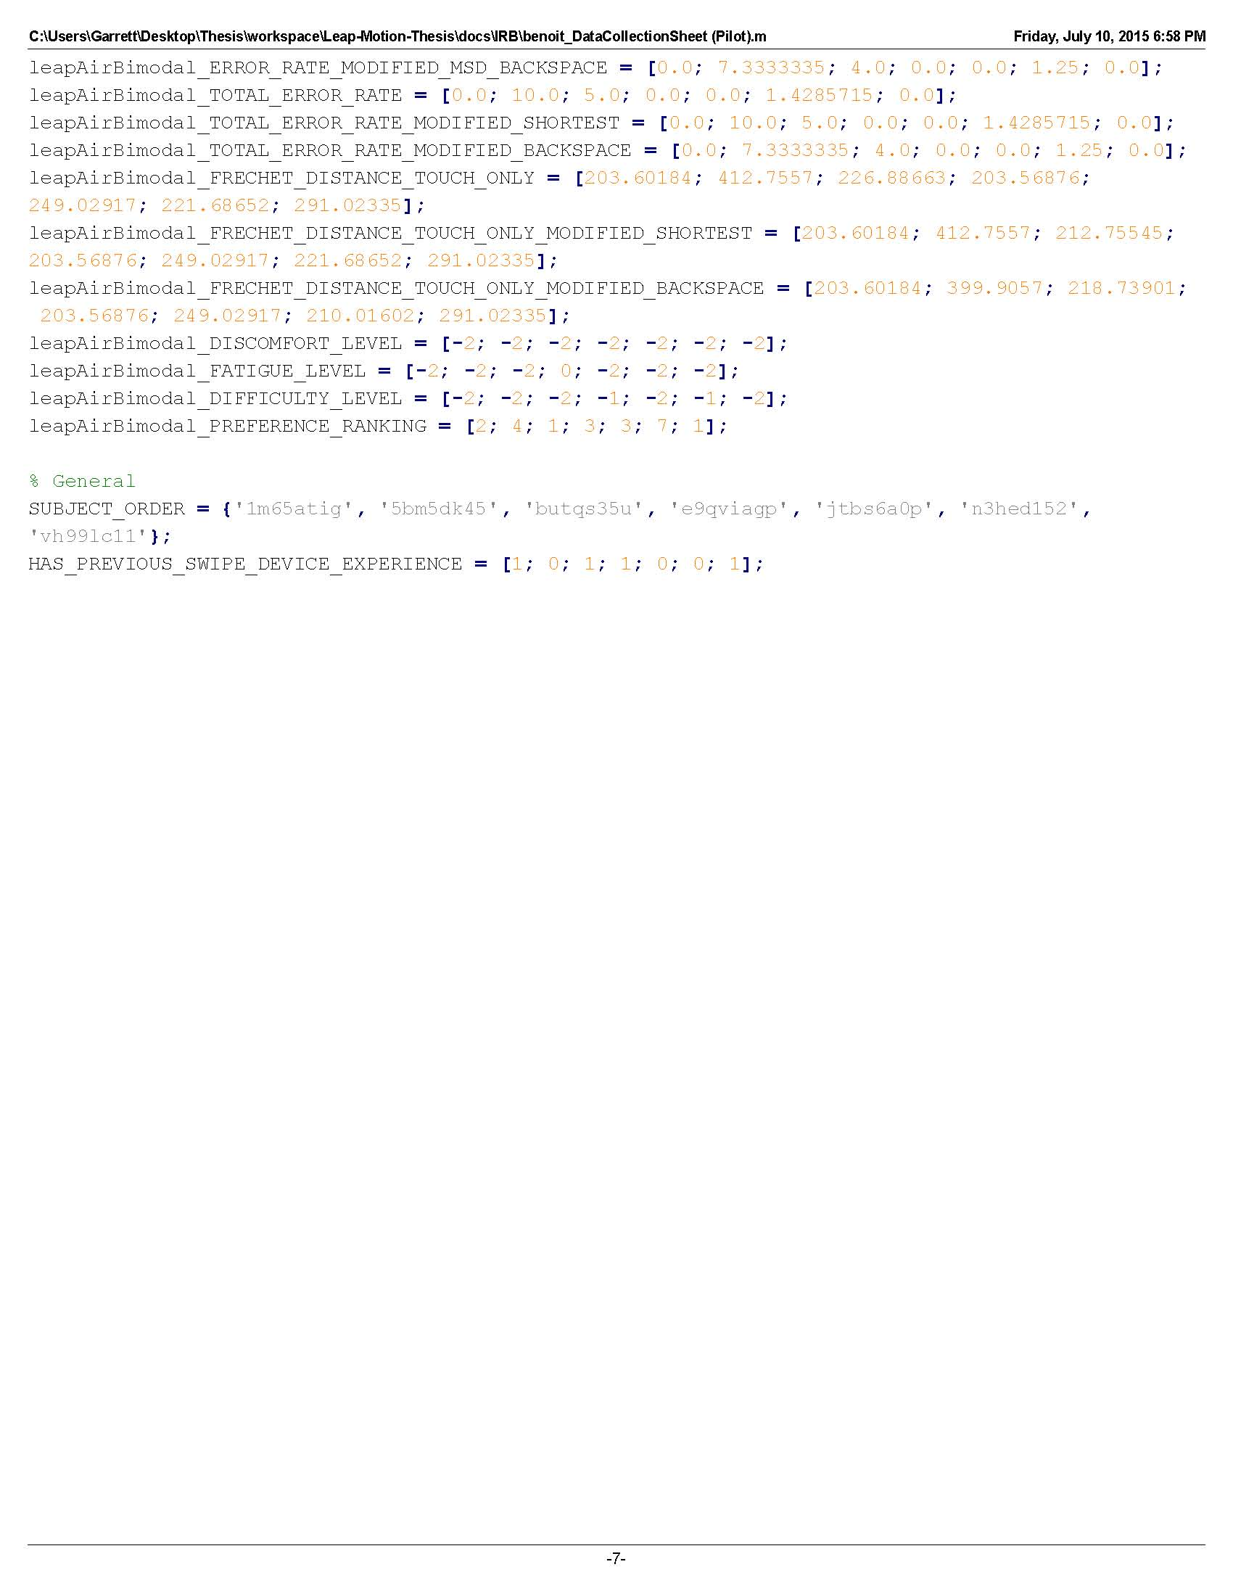

**Appendix G: benoit_SampleSizeCalculations.pdf**

The sample size justification shows how the sample size was chosen and which variables and keyboard comparisons were used to calculate it. Some of the recorded variables were deemed not critical in answering the research objectives and were left out for this calculation (e.g., reaction times, number of touches that were simulated, Likert scales, rankings). The sample size justification was submitted alongside the protocol and can be found with other submitted materials.

